Flora Mae Donald
May 1, 1935 - October 10, 2023

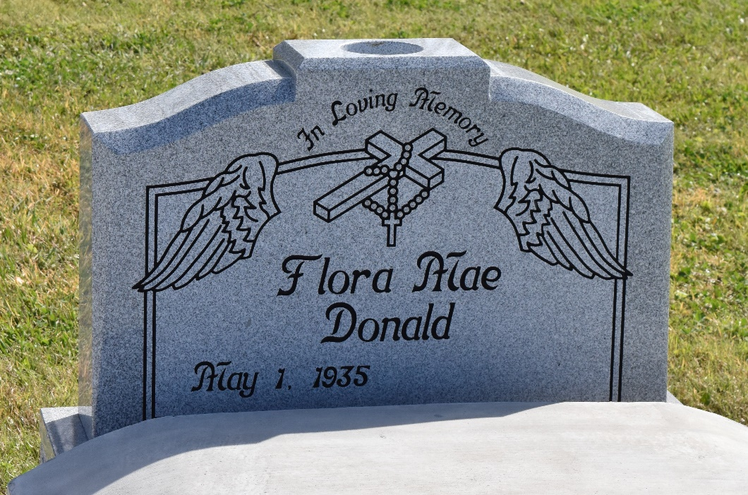

Flora Mae Donald entered life on May 1, 1935 to John Donald, Sr. and Hilda Adams Donald. She peacefully transitioned on Tuesday, October 10, 2023. She was a graduate of McDonough 35 Senior High School and later attended Southern University of Baton Rouge.
Flora Mae was raised in a God loving home with prayers and frequent attendance to mass where she was a member of St. Philip Catholic Church. Whenever you visited her, she was surrounded by many prayer books and there was always a rosary in hand. Flora Mae worked for the Community Action Program and was Director of St. James Parish HeadStart Program. When Flora Mae health started to decline she entered willingly to Chateau St. James Rehab and Retirement facility in Lutcher, La. where she lived for ten years until her passing.
Flora Mae was preceded in death by her parents, John Sr. and Hilda Donald, two brothers, John Jr. and Timothy Donald. Flora Mae leaves to cherish her memories; one son Randall (Ira) Donald, one sister, Lorraine (MacArthur) Webster and two sisters-in-law, Rose Miller Donald and Flora Louper Donald. Two grandchildren; Roman (Aneshia) and Randi Donald and six great grandchildren as well as several nieces including Annette, Rona, Nasha, Courtney and Chandra and nephews John III, Duane, and Corey as well as other relatives and friends.
The family extends their thanks to the many doctors, nurses, and caregivers at the facility for their endless services.
A Mass of Christian Burial honoring her life will be held on Thursday, October 19, 2023 for 11:00 am at St. Philip Catholic Church, 1175 La-18, Vacherie, La 70090. Visitation begins for 9:00 am. Father Mike O'Rourke celebrant. Burial to follow in church cemetery.

Treasures of Life Center for Life Funeral Services, Gramercy, Louisiana

