Isabelle (Raphael) Dorest

November 14, 1915 – December 12, 1999

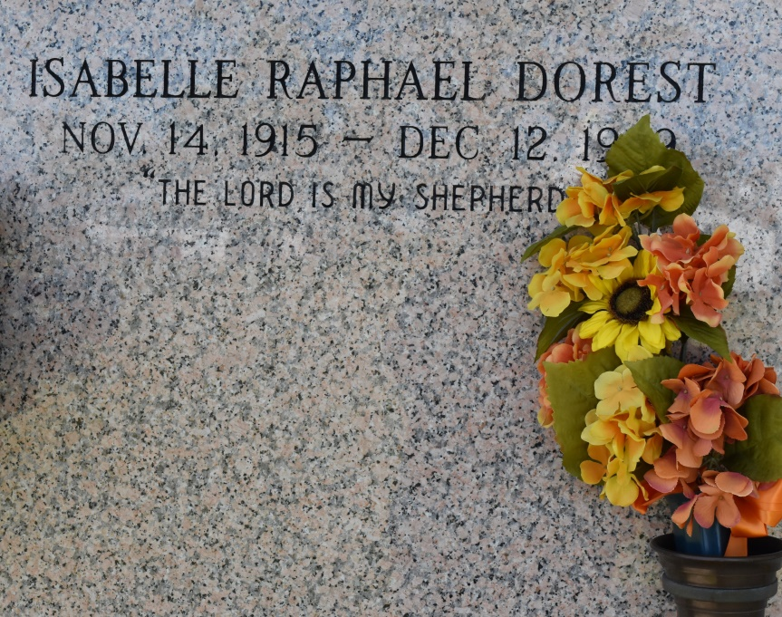

VACHERIE – Isabelle "Zabelle" Raphael Dorest, 84, a native of Vacherie and resident of Wallace for 79 years, died Dec. 12. She was the wife of the late Leonard G. Dorest and mother of Cleo Williams, Bonita Young, Wanda Boudreaux, Gilbert, Hamilton, Alfred, Jana and Desiree Dorest and the late Mable Warner and Vernon Dorest.  
  
She was also the daughter of the late Pierre and Feliciana Hymel Dorest and sister of the late Odile Harris, Evelyn Harris, Lorenza Joseph, Baline Taylor, Florida Fernandez and Rose, Adeline, Flora, Leonard, Lazarus and Baltron Raphael. She is also survived by 25 grandchildren and 26 great-grandchildren. She was preceded in death by two grandchildren.  
  
Services are today at 10 a.m. at St. Philip Catholic Church, Vacherie, with interment at the church mausoleum. Visitation starts at 8 a.m.

Unknown source