James Dufresne

June 18, 1940 – September 30, 2021

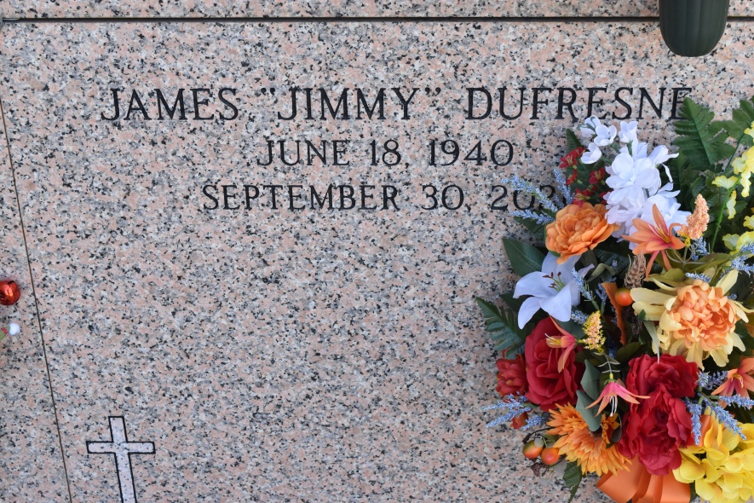

James "Jimmy" Dufresne passed away at the age of 81 on Thursday, September 30, 2021, at his home. He was a native and resident of Wallace, Louisiana. He is survived by his brother, Leroy Dufresne, and numerous nieces, nephews, cousins, and friends. Jimmy is preceded in death by his parents, Denis J. Dufresne and Myrtle Zeringue Dufresne; brothers, Marion, Joseph and Carol Dufresne; sister, Marie Therese D. Dufresne (Amilcar); and niece, Denise Dufresne.

A visitation will be held in honor of Jimmy on Monday, October 4, 2021, at 9:00 am at St. Philip Catholic Church in Vacherie, LA, until a Mass of Christian Burial at 11:00 am. Interment will follow in St. Philip Cemetery Mausoleum. In lieu of flowers, Masses are preferred. Rose Lynn Funeral Services is in charge of the arrangements. To view or sign the online guestbook, visit [www.roselynnfuneralhome.com](http://www.roselynnfuneralhome.com/).

Published by The Advocate (Baton Rouge, LA) from Oct. 2 to Oct. 4, 2021.