Mary Ann (Tassin) Dugas

October 24, 1924 – August 10/2012

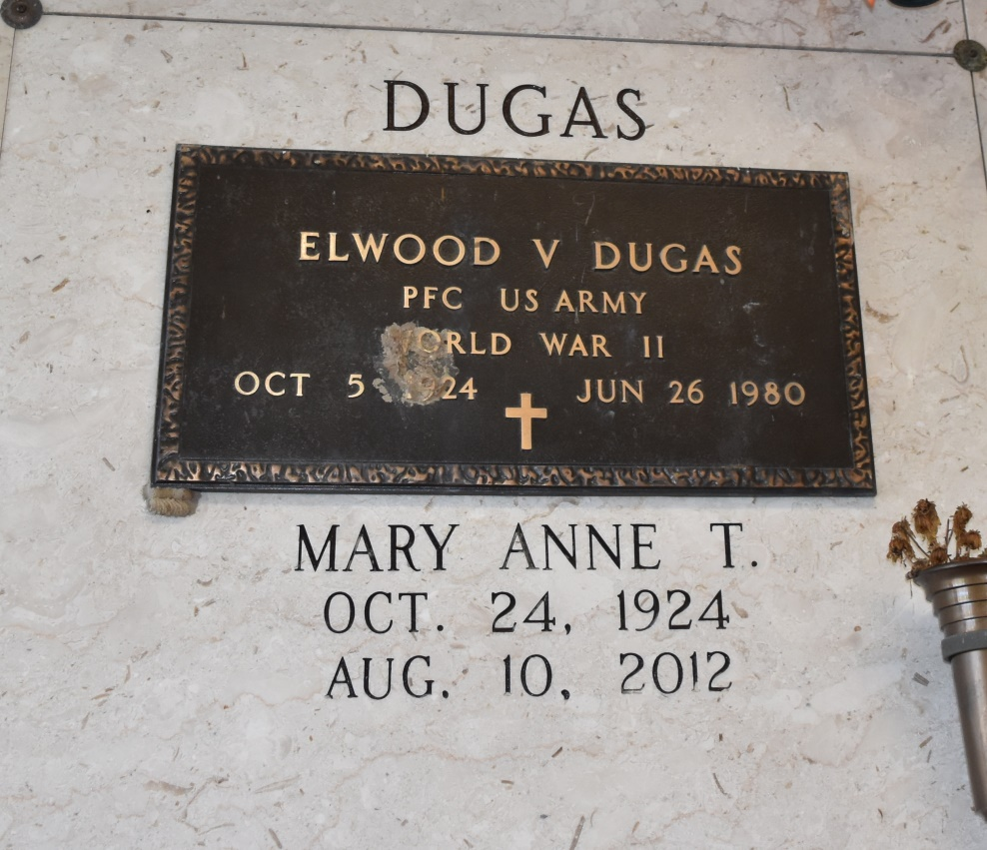

Mary Anne Tassin Dugas, age 87, peacefully passed away on Friday, August 10, 2012, surrounded by her family. Beloved wife of the late Elwood Victor Dugas, daughter of the late Isaie Tassin and Marie Webre Tassin, and sister of the late Lewis Joseph Tassin. Survived by her sister Winnie Rose Tassin Chauvin (Philip, Jr.), sister-in-law, Betty Petit Tassin, along with nieces, nephews, relatives, and friends. Special thanks to River Regions Hospice in Harahan for the loving care given to her. Relatives and friends of the family are invited to attend the Funeral Mass at St. John the Baptist Catholic Church, 2349 Hwy. 18, Edgard, LA 70049, on Tuesday, August 14, 2012 at 11:00 a.m. A visitation will be held at the church beginning at 9:00 a.m. Interment will follow in St. Philip Cemetery. To view and sign the guest book, visit [www.lakelawnmetairie.com](http://www.lakelawnmetairie.com/)

Published by The Times-Picayune (LA) from Aug. 11 to Aug. 13, 2012.