Cecilia (Waguespack) Faucheux

May 11, 1913 – June 6, 2006

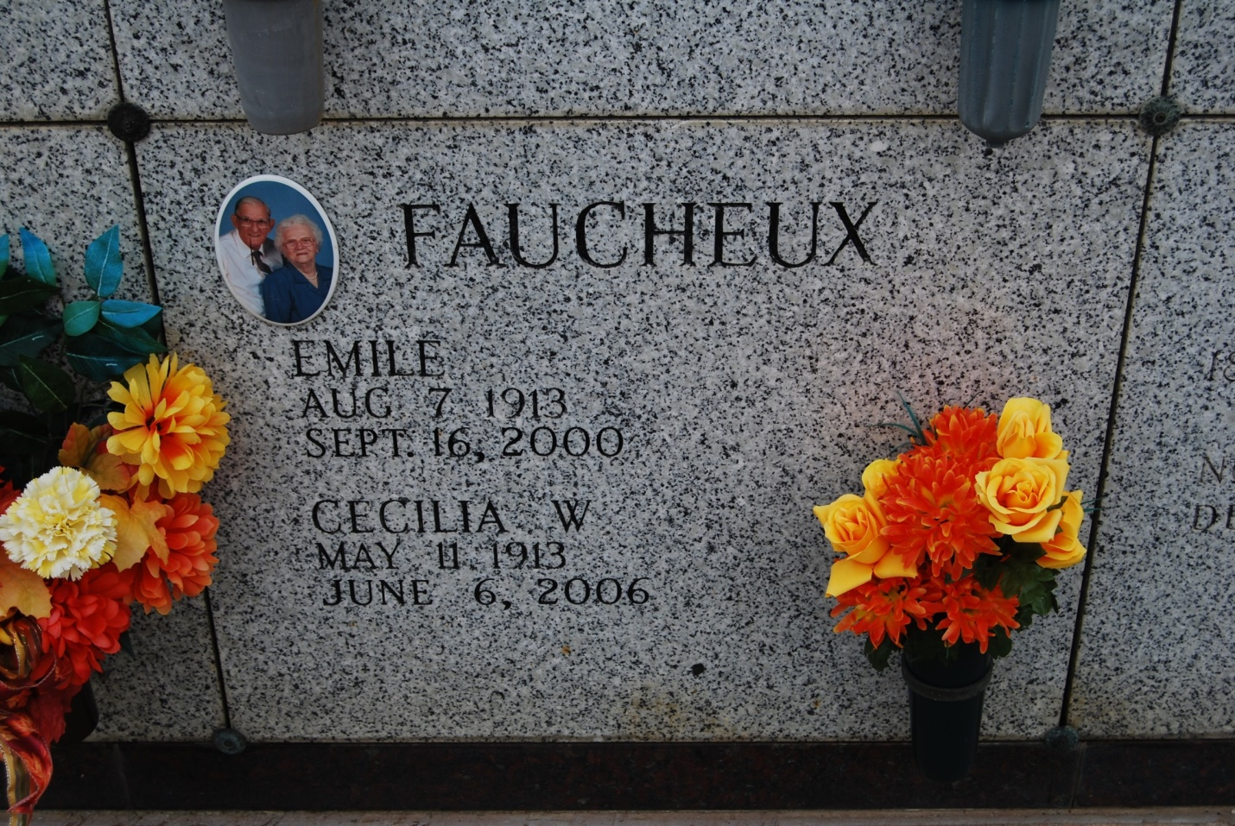

Photo by Kerry Keller

Faucheux, Cecilia Waguespack "Suet" - A homemaker and a resident of Thibodaux, she died Tuesday, June 6, 2006, at 5:46 p.m. in Thibodaux. She was 93 and a native of Vacherie. Visiting at St. Philip Catholic Church in Vacherie on Friday, June 9, from 8:30 a.m. until Mass of Christian Burial at 11 a.m., with the Rev. Michael Miceli, celebrant. The rosary will be recited at the church at 9 a.m. Friday, led by the Catholic Daughters. Entombment in the church mausoleum.  
 She is survived by her daughter and son-in-law, Geraldine and Ray Labat of Crowley; two sons and daughters-in-law, Norman and Cynthia Faucheux of Hammond and Emile Jr. and Lana Faucheux of Vacherie; seven sisters and three brothers-in-law, Bessie Haydel, Mary Grace Trosclair, Ethelyn and Emile Trosclair, Anna Mae and Robert Pavy, Mathilide Nugent, Honorine Becnel, and Romana and Nolan Veillion; brother and sister-in-law, Herman and Geraldine Waguespack; sister-in-law, June T. Waguespack; and 16 grandchildren, 27 great-grandchildren and three great-great-grandchildren.  
 She was preceded in death by her husband, Emile "Conoon" Faucheux Sr.; parents, Rosney and Cecilia Schexnayder Waguespack; daughter, Claudia Senft; brother, Joseph Waguespack; and four brothers-in-law, George Haydel, Jerry Trosclair, Walter Nugent and Roland Becnel. She was a lifelong member of Catholic Daughters of the Americas St. Philip Court.  
 In lieu of flowers, please make memorial donations to St. Philip Catholic Church, Vacherie. Alexander Funeral Home, Lutcher, is in charge of arrangements.   
  
Published in The Advocate, Baton Rouge, LA on June 8, 2006