Emile J. Faucheux Sr.

August 7, 1913 – September 16, 2000

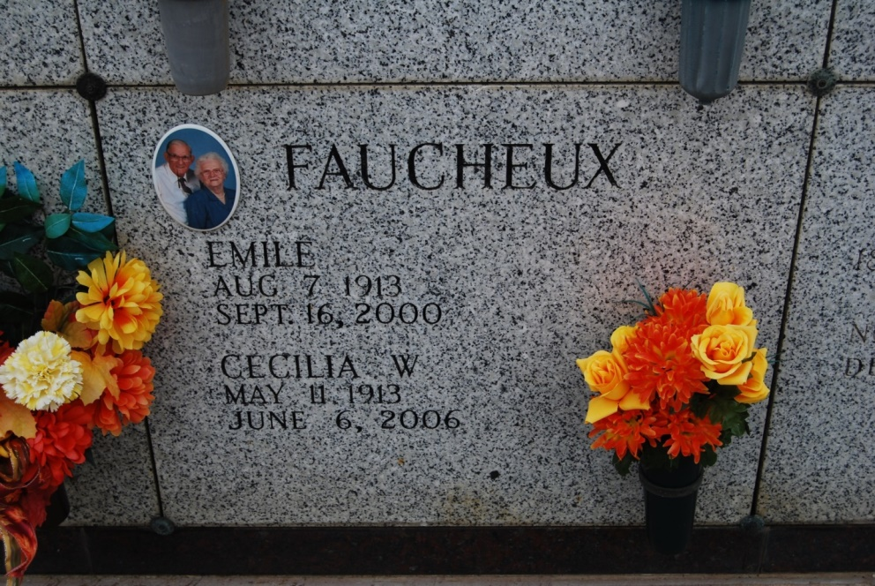

Photo by Kerry Keller

VACHERIE - Emile J. "Canoon" Faucheux Sr., 86, died Saturday, Sept. 16, 2000, at his home. He was a retired employee of the Vacherie House and a longtime member of Knights of Columbus Council No. 1514, Vacherie. Survivors include his wife, Cecilia M. "Sue" Waguespack Faucheux, Vacherie; daughter, Geraldine Labat, Crowley; two sons, Emile J. Faucheux Jr., Vacherie, Norman Faucheux, Hammond; 17 grandchildren and 27 great-grandchildren. A daughter, Claudia Senet; six sisters, Amelia Roussel, Ludivine Millet, Odette Rodrigue, Jeanne Chappais, Elma Cambre and Carmen Rodrigue; and three brothers, Ferducie, Etienne and Felicie Faucheux; preceded him in death. The Rev. David Chauvin conducted the funeral at noon today at St. Philip Catholic Church, Vacherie, and entombment was in the church mausoleum.

Unknown source

\*\*\*\*\*

A retired employee of Armond Sugar House, Vacherie, and a lifelong resident of Vacherie, he died Saturday, Sept. 16, 2000, at his home. He was 87. Visiting at St. Philip Catholic Church, Vacherie, from 8 a.m. until Mass of Christian Burial at noon Monday, celebrated by the Rev. David Chauvin. Entombment in church mausoleum. Survived by his wife, Cecilia M. "Sue" Waguespack Faucheux, Vacherie; a daughter and son-in-law, Geraldine and Raymond Labat, Crowley; two sons and daughters-in-law, Emile J. Jr. and Lana Faucheux, Vacherie, and Norman and Cindy Faucheux, Hammond; 17 grandchildren; and 27 great-grandchildren. Preceded in death by his parents, Landry and Clothilde Oubre Faucheux; a daughter, Claudia Senft; six sisters, Amelia Roussel, Ludivine Millet, Odette Rodrigue, Jeanne Chappais, Elma Cambre and Carmen Rodrigue; and three brothers, Ferducie, Etienne and Felicien Faucheux. He was a longtime member of Knights of Columbus Council No. 1514, Vacherie. H.C. Alexander Funeral Home, Lutcher, in charge of arrangements.

Advocate, The (Baton Rouge, LA) - Monday, September 18, 2000