Noelie (Tregre) Faucheux

December 26, 1896 – May 7, 1986

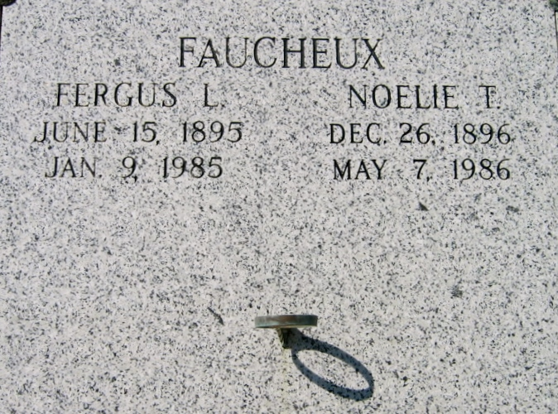

Photo by Bobby

FAUCHEUX

Mrs. Noelie Tregre Faucheux. At the residence in Wallace, La. on Wednesday, May 7, 1986 at 4:15 p.m. Wife of the late Fergus Faucheux. Daughter of the late Felix and Lezima Tassin Tregre. Mother of Mrs. Florent (Enola) Faucheaux, Mrs. Roby (Mabel) Cazenave, Mrs. Thomas (Vivian) Waguespack, Lewis, Lynn and Lucien Faucheux, all of Vacherie, La., Malvin Faucheux of Bridge City, Clarence Faucheux of Boutte and Clifford Faucheux of Baton Rouge. Sister of Mrs. Lazima T. Schexnayder of Donaldsonville and the late Martha Poirrier, Linda Loup, Florien and Lucien Tregre. Also survived by 31 grandchildren, 17 great-grandchildren and 1 great-great-grandchild. Mother-in-law of the late Florent Faucheaux. Grandmother of the late Joan Cazenave. A native of St. James amd a resident pf Wallace. Age 89 years.

Relatives and friends of the family are invited to attend the Mass of Christian Burial at St. Philip Catholic Church, Vacherie, La., on Friday, May 9, 1986 at 11 a.m. Interment St. Philip Mausoleum, arrangements by Ourso. Visitation at the St. Philip Catholic Church from 8 a.m. until funeral time Friday.

Times-Picayune/States Item, New Orleans, LA

Friday, May 9, 1986, p. A-29