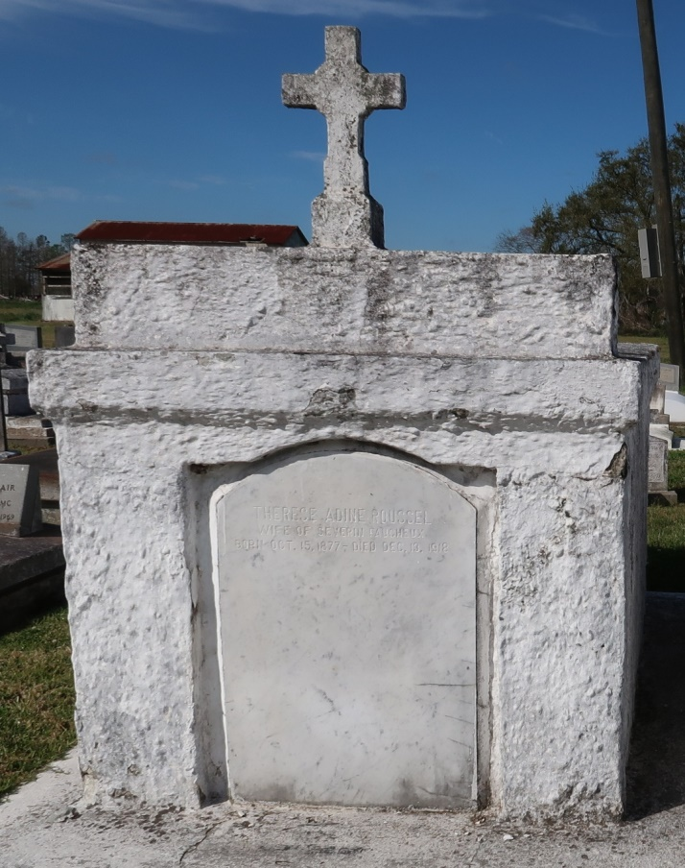Therese Adine (Roussel) Faucheux

October 15, 1877 – December 13, 1918

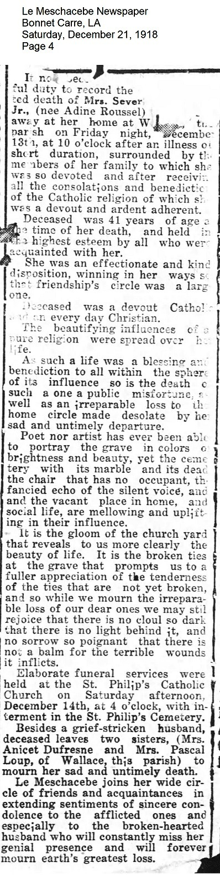

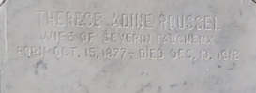

Newspaper clipping contributed by

Mary Agnes Hammett