Glenda Ann (James) Fletcher
April 14, 1954 – February 16, 2025

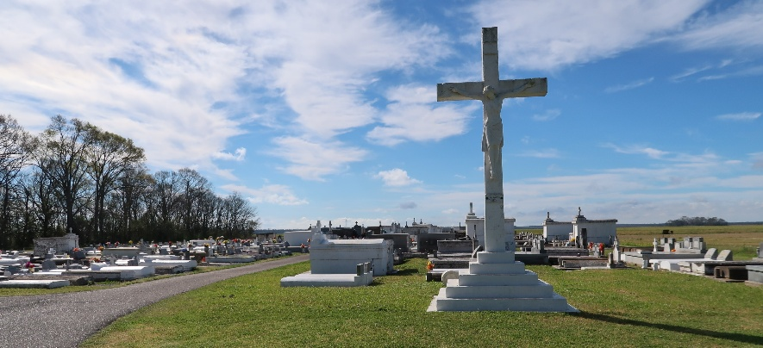

On God’s own time, in God’s own way, and for God’s own purpose, our heavenly father called his beloved Glenda Ann James Fletcher from this earthly life on February 16, 2025 at the age of 70 to reside with him in a heavenly place he has prepared for her.
Glenda was born in New Orleans, Louisiana on April 14, 1954. She was a native of Vacherie, Louisiana. She was the third child of Robert and Louise Harris James. On her arrival, she was greeted by her brothers, Junior and Ronald James. She was later joined by Linda, Lois, Vanessa, Tyrone, Rodney, Yvette, Angie, Randy and Dwayne James.
She was a proud graduate of St. James High Class of 1972. After graduation, she was employed by Turner Industries for many years, but her favorite job was with Rhodes Insurance because it allowed her to show compassion and love for everyone through words and action. She never met a stranger and was a living example of the Prayer to St. Francis, “Lord make me an instrument of our peace” . Her greatest moments were spent with her sons, Chaddrick and Cody Fletcher. Her grandchildren were the delight of her eyes. Her love for GOD and service to others, led her to become a member of the Knights of St. Peter Claver Ladies Auxiliary, where she remained a member for over forty years with St. Philip Court #45 and she also served as the Grand Lady and Secretary. She was also a dedicated member of Father John A. McShane Fourth Degree Ladies of Grace Chapter #23, Our Lady of Peace Court 161, and a member of Southeast Central Committee District II.
She leaves to cherish memories of her loving sons, Chaddrick (Anissa) Fletcher and Cody Fletcher; Special Friend Mr. Larry Fletcher; siblings, Linda Johnson, Lois Harris, Vanessa James, Tyrone James, Rodney James, Yvette J.(Alexander) Stewart, Angie J. (Micheal) Broden, Randy James and Dwayne (Lovenia) James; grandchildren, Jahron (Jasmine) Banks, Donchelle Harris, Cameron Fletcher, Alaun Fletcher, Kayden Washington; great grand children, Jru Cunningham, Dayci Smith, Alauni Fletcher, Jahvion Banks, Cameron Cherry; aunts, Irene Ester, Beatrice Joshua, Sedonia (Eddie) Garrison, Girtie Williams and Maebell Harris; uncle, Raymond Harris; adopted sisters, Janice (Owen) Steward, Andra Cambre, Anita (Craig) Duronslet, and Patricia Moses; Prayer Partner, Flora Donald; god children, Derrick Adams, Alissa Cureau, Reva Fletcher, Justin Collins; God Mother, Felisha Fiffie; a host of nieces, nephews, cousins, and friends.
Glenda is proceeded in death by her parents, Robert and Louise Harris James; her brothers, Junior and Ronald James; maternal grandparents, Ernest and Beatrice Harris; Paternal grandparents, Lemar and Margaret James; and a host of aunts and uncles.
The family would like to invite family and friends to a public visitation on Friday, February 21, 2025 at Treasures of Life Funeral Services, 315 E. Airline Hwy., Gramercy, LA 70052 from 6:00-8:00pm. A Mass of Christian Burial will follow on Saturday, February 22, 2025 at St. Philip Catholic Church, 1175 LA 18, Vacherie, LA 70090 for 10:30 am; visitation begins for 8:00am. Interment St. Philip Catholic Church Cemetery.

Treasures of Life Funeral Services, Gramercy, Louisiana
Sunday, February 23, 2025

