Barbara Ann (Adams) Gauthier

July 4, 1940 - October 16, 2012

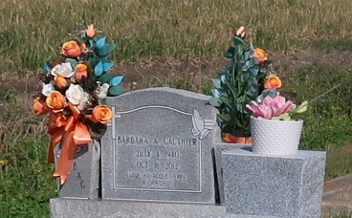

Barbara Ann Gauthier passed away on October 16, 2012, at the age of 72 years old. Daughter of the late Blanche and Abraham Adams, Sr. Mother of Kit (Myron) Jarrow, Reggie (Paulette) Thomas, Sr., and Terry Gauthier. Sister of Sandra (Warner) Sylvain, Terrel "Chris" Adams, Abraham (Rosemarie) Adams, Jr., Renaldo Gauthier and Kebin Adams. Sister of the late Rosemarie Adams Johnson, Raymond Adams, Beverly G. Williams and Donald Adams. Grandmother of Devyn Jarrow, Dontrell Hall, Reggie Thomas, Jr., LaFarrin Darensbourg, and Rochon A. Thomas. Also survived by a host of nieces, nephews, other relatives and friends.

Relatives and friends of the family, employees of Cajun Construction at UCC/Dow, Zapps Potato Chips, Cornerstone Industries, Home Depot, members of New Jerusalem Baptist Church and St. John the Baptist Catholic Church are invited to attend the funeral services at St. John the Baptist Catholic Church, 2361 Highway 18, Edgard, La. on Saturday, October 20, 2012 for 11:00 a.m. Father Robustiano Morgia will be officiating. Visitation is from 9:00 a.m. until time of service. Funeral entrusted to The Baloney Funeral Home, LLC., 399 Earl Baloney Street, Garyville, La., 985-535-2540. Interment will be at St. Philip Cemetery, Wallace, La. Condolences can be expressed at [www.baloneyfuneralhome.com](http://www.baloneyfuneralhome.com/).

Published by The Times-Picayune (LA) from Oct. 18 to Oct. 19, 2012.