Joan Ann (Schexnayder) Gautreau

September 9, 1945 – January 23, 2015

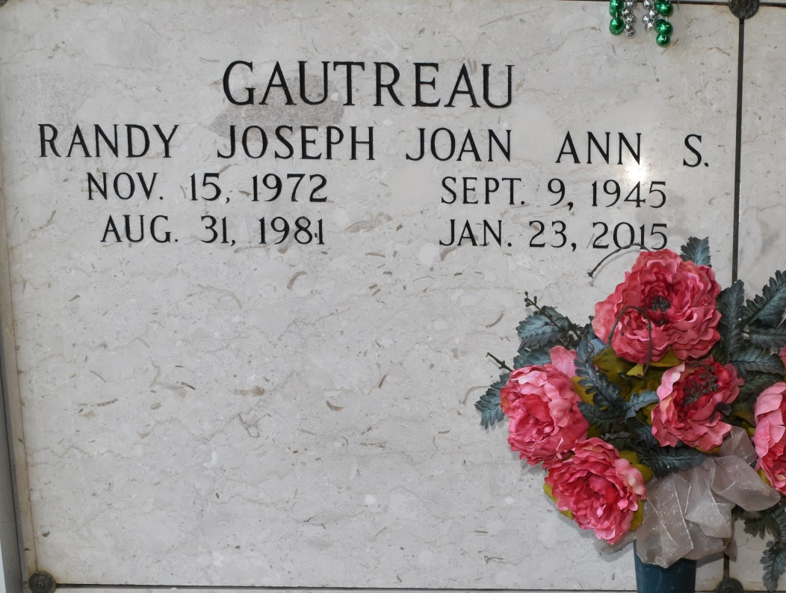

A native of St. James and resident of Donaldsonville, Joan Ann Gautreau passed away Friday, January 23, 2015 at the age of 69. She is survived by her son, Paul Gautreau; grandchildren, Amber Hand, James, Elizabeth, Isabelle, and Dillon Gautreau; brothers and sisters-in-law, Louis and Jackie, Robert and Vickie, James, Sidney and Audrey, Henry and Julia, George; and numerous nieces and nephews. She is preceded in death by her husband, Warren Gautreau; son, Randy Gautreau; parents, Lionel and Beatrice Labiche Schexnayder; and sister, Lucy Schexnayder.

There will be a visitation at St. James Catholic Church in St. James, Wednesday, January 28, 2015 from 9:00 a.m. until a Mass of Christian Burial at 11:00 a.m. with Rev. Paul Yi, celebrant. Entombment to follow in St. Philip Catholic Church Mausoleum. The family would like to extend their gratitude to Dr. Dennis DeSimone and to the oncology staff at Woman's Hospital in Baton Rouge. To offer condolences to the family, please visit [www.oursodonaldsonville.com.](http://www.oursodonaldsonville.com/)

Published by The Advocate (LA) from Jan. 25 to Jan. 28, 2015.