Carolyn Kathleen (Savoie) Grant
June 2, 1931 – October 8, 2016

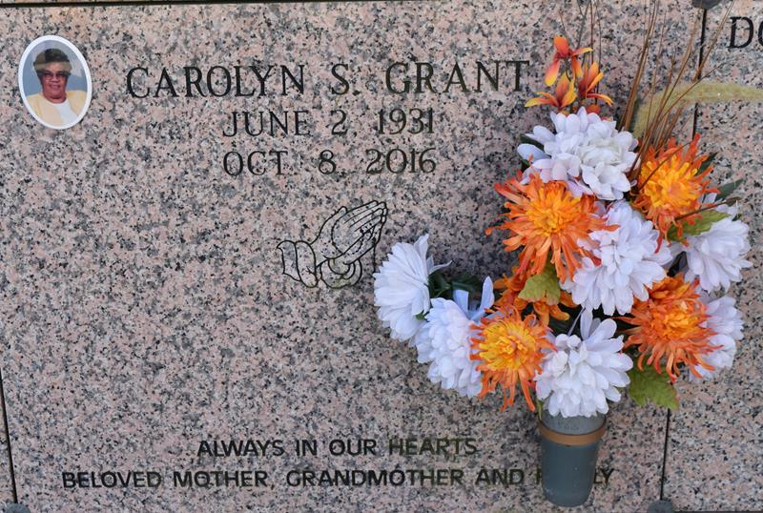

Carolyn "Kathleen" Savoie Grant, age 85, transitioned to her heavenly home on Saturday, October 8, 2016.
Wife of the late Alfred E. Grant, Sr. and was a devoted mother, grandmother, great-grandmother, sister and friend. Carolyn leaves her loving and devoted family to honor and cherish her memories, one daughter, Charlotte Grant of Jefferson, LA and two sons Alfred Grant, Jr. (Elaine) of St. James, LA and Rickey Grant (Hilda) of Zachary, LA.; six grandchildren, and eight great-grandchildren; two sisters, Mathilde S. Smith of New Orleans, LA., and Alma S. Johnson of Edgard, LA.; Two brothers, Charlie Savoie (Janette) of New Orleans, LA. and Jerry Savoie (Mickey) of Reserve, LA; one brother-in-law, Emil August, Jr. of Edgard, LA.; one sister in law Loretta Savoie: one devoted aunt, Rose (Child) Alexander of Marreo, LA.; and a host of friends, nieces, nephews, and other relatives.
She was preceded in death by her father, Blaine Savoie, Sr.; mother, Beulah Borne Savoie; Brothers, McKinley Savoie, Jr. and Joseph Savoie; Sisters, Lucretia Briscoe and Earnestine August.
The Mass of Christian Burial will be held on Saturday, October 15, 2016 for 11:00 am. Visitation will begin at 8am followed by the Rosary at 9am. at St. Philip Catholic Church, 1175 Highway 18, Vacherie. Entombment church cemetery. Her final care has been entrusted to Treasures of Life Center for Life Funeral Services.

The New Orleans Advocate, Louisiana
Oct. 12 to Oct. 19, 2016

