Lester John Gravois

May 16, 1922 – December 14, 2020

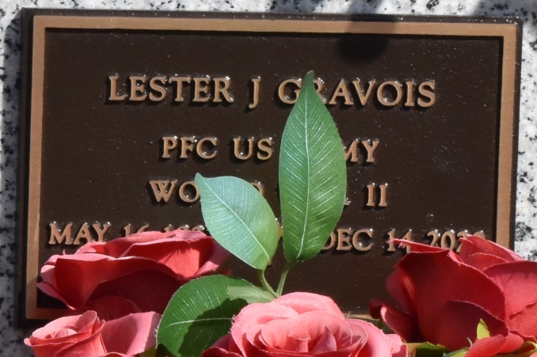

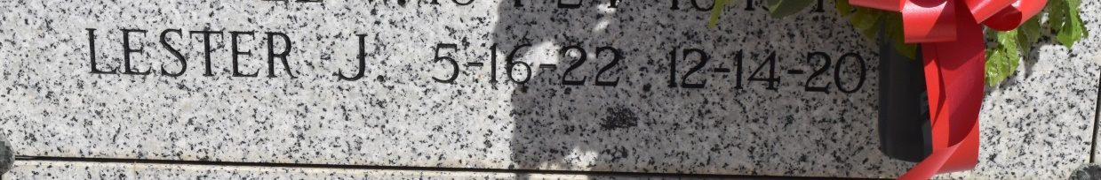

Vacherie - Lester John Gravois, a native of Vacherie and a resident of Thibodaux passed away on Monday, December 14, 2020 at the age of 98.  
 A Mass of Christian Burial will be held in his honor on Thursday, December 17, 2020 at St. John the Evangelist Catholic Church at 1:00 pm. Due to CDC Regulations, the family will not be having a visitation prior to Mass. A private interment will follow.  
 He is survived by his two sons, Bobby Gravois and wife Susie, and Denis Gravois and wife Denise; four daughters, Leslie "Tookie" Terry and husband Billy, Margaret Scarpero and husband C.J., MiMi Duncan and husband Doug, and Jean Lyons; 26 grandchildren and 32 great-grandchildren; and siblings, Earl Gravois, Charles Gravois, Rosa Songy, and Jackie Waguespack.  
 He was preceded in death by his beloved wife of 65 years, Lucille Waguespack Gravois; three sons, Ross Gravois, Howard Gravois, and Billy Gravois; one daughter, Mary Eileen Gravois Price; three grandsons, Andrew Lyons, Jackson Price, and Will Price; and parents, Ozane and Louise Gravois.  
 He was a proud veteran in the US Army during World War II and was a member of the Knights of Columbus Council 1514 in Vacherie for over 60 years. He will be remembered for his catchy song, "Show Me the Way to go Home", and his amazing whistling skills. He will be dearly missed by all his loved ones.  
 Pallbearers will be Ross Gravois, Jude Gravois, Mark Gravois, John Caldarera, Chris Gravois, T.J. Declet, and Patrick Lyons.  
 The family would like to thank his caregivers, especially Laura Simoneaux for her undying love, care, and devotion for their dad and the entire family.  
In lieu of flowers, donations can be made to a [charity of your choice](http://www.legacy.com/obituaries/houmatoday/condolences-charities.aspx?keyword=coycalz&pid=197293389).  
Thibodaux Funeral Home is in charge of arrangements.

Published by Houma Today (LA) from Dec. 14 to Dec. 16, 2020.