Jerrold Philip Gros Jr.

July 8, 1981 – June 18, 2016

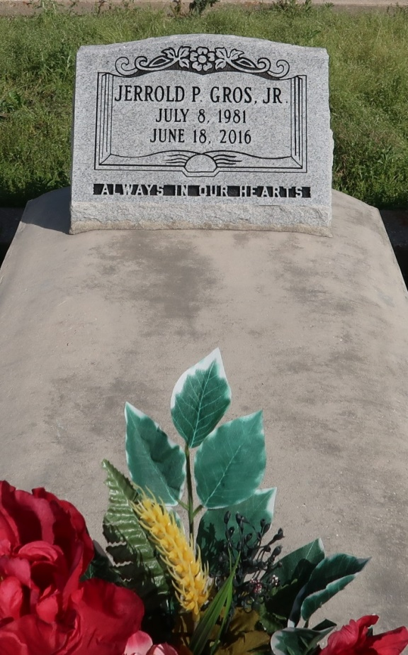

Jerrold ""JR"" Philip Gros Jr., a resident of Vacherie, LA, graduate of the class of 2000, St. James High School and member of St. James Catholic Church, departed this life on Saturday, June 18, 2016 at the young age of age 34. He is survived by wife, Christal Mollere Gros, children, Jaimier, Kadence, Kaysen Williams; stepchildren Krazon'shae, Kralon'shae, Christopher, and Tyresse Nicholas; mother, Althea W. Gros, three sisters, Rashawn Brooks, Jerrolyn Gros, and Jenna Lee Gros; godmother, Cynthia Walker, godfather, Kenneth D. Oubre, godchild, Ja'Marin Octave, nephew, John Brooks Jr., niece, Imani Brooks, and a host of other relatives and friends.

He was preceded in death by his father Jerrold Gros Sr., fraternal grandparents Joseph Pershing Gros Sr. and Loretta K. Gros, maternal grandparents, George Walker Sr. and Lois O. Walker, uncles Joseph Pershing Jr., Lamont James Sr., Nathaniel Gros, and Clint Walker; aunts Geraldine G. Oubre and Camille Gros.

A celebration of life will be held on Saturday, June 25, 2016 at 11:00am from St. James Catholic Church, 6613 Hwy 18, St. James, La.; Father Christopher Decker, celebrant. Viewing begins at 9:00am. Interment St. Philip Catholic Church Cemetery, 1175 Hwy 18, Vacherie, LA. Treasures of Life, Center for Life Funeral Services entrusted with final arrangements.

Published by The New Orleans Advocate from Jun. 21 to Jun. 25, 2016.