George Grow Sr.

March 1, 1923 – May 12, 2002

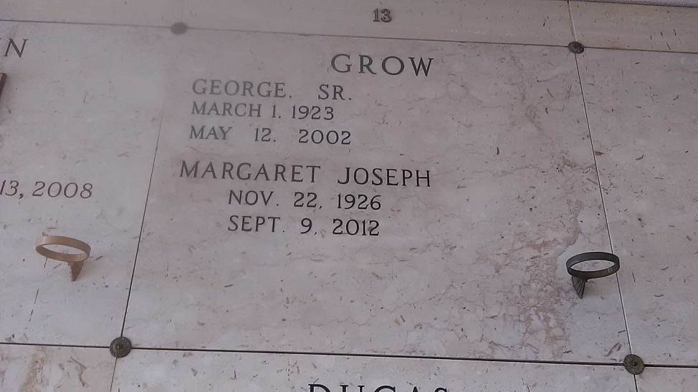

Photo by TMB

George (K-Line) Grow of Wallace, LA on Sunday, May 12, 2002 at his residence. Son of the late Aurelien and Augustine Mitchell Grow. Beloved husband of Margaret Joseph Grow. Beloved father of Shelia G. Baloney and Hamilton Growe and the late George Grow Jr. Brother of Pierre, Lazin, and Aurelien Grow, Bernadine G. Bartholomew, Pearl G. Clark and the late John Grow. Also survived by 3 grandchildren, Brandy and Heather Growe and Courtney G. Baloney; 1 great grandchild, Lauryn E. Baloney; 2 daughters-in-law; and a host of nieces, nephews, cousins, other relatives and friends. Devoted friend of Joseph Fiffie Sr. A native and resident of Wallace, LA. Age 79 years.

Unknown source

\*\*\*\*\*

VACHERIE - George "K-Line" Grow, 79, a native and resident of Wallace, died May 12. He was the husband of Margaret Joseph Grow and father of Sheilia Baloney and Hamilton and the late George Grow Jr.  
 He was the son of the late Aurelien and Augustine Mitchell Grow and brother of Bernadine Bartholomew, Pearl Clark and Pierre, Lazin, Aurelien and the late John Grow.  
 He is also survived by three grandchildren and one great-grandchild.  
 Services were May 16 at St. Phillip Catholic Church, Vacherie, with interment at the church mausoleum.

L'Observateur (La Place, LA)

Tuesday, May 21, 2002