Nevelle Orlando Grow

August 10, 1987 – July 25, 2011

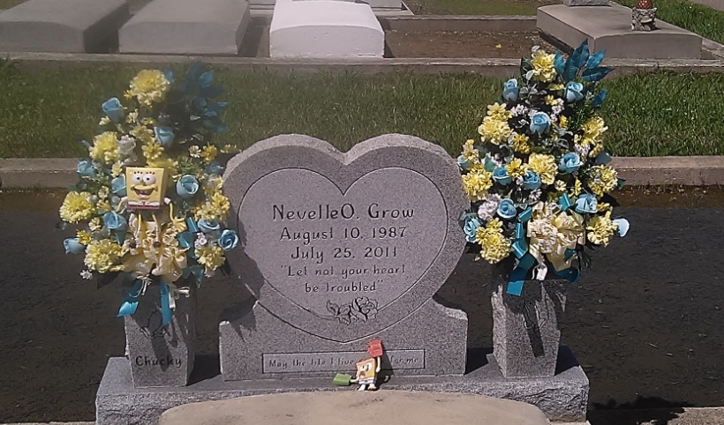

Photo by TMB

"I can do all things through Christ who strengthens me." Phillippians 4:13  
  
 Nevelle Orlando Grow, age 23, graduate of University of New Orleans and 2005 graduate of West St. John High School, departed this life on Monday, July 25, 2011. He was born on August 10, 1987 to loving parents Lazin Jr. and Esther Nailor Grow of Vacherie, LA. Survived by his parents; sister, Natalie (Anthony) Goudia; maternal grandmother, Grace Dumas Nailor; and host of aunts, uncles, and cousins. Preceeded in death by his paternal grandparents: Lazin Sr. and Enide Marshall Grow; maternal grandfather, James T. Nailor Sr.  
 Relatives, friends, and employees of Imperial Sugars, Walmart, LA State Government, First Baptist Church of Vacherie, La., St. Philip Catholic Church are invited to attend the Funeral Mass of Christian Burial at St. Philip Catholic Church, 1175 Hwy. 18, Vacherie, LA. 70090 on Saturday, July 30, 2011 at 1PM. Visitation at 11:00 AM until time of service. Father Chris Decker, celebrant. Interment in the Church Cemetery.  
 Arrangement by The Baloney Funeral Home LLC, 399 Earl Baloney Street, Garyville, La. 70051. 985-535-2540. Guest may sign the register at [www.baloneyfuneralhome.com](http://www.baloneyfuneralhome.com).

Times-Picayune, The (New Orleans, LA) - Friday, July 29, 2011