Lawrence Harrison Sr.

April 23, 1933 – December 4, 2007

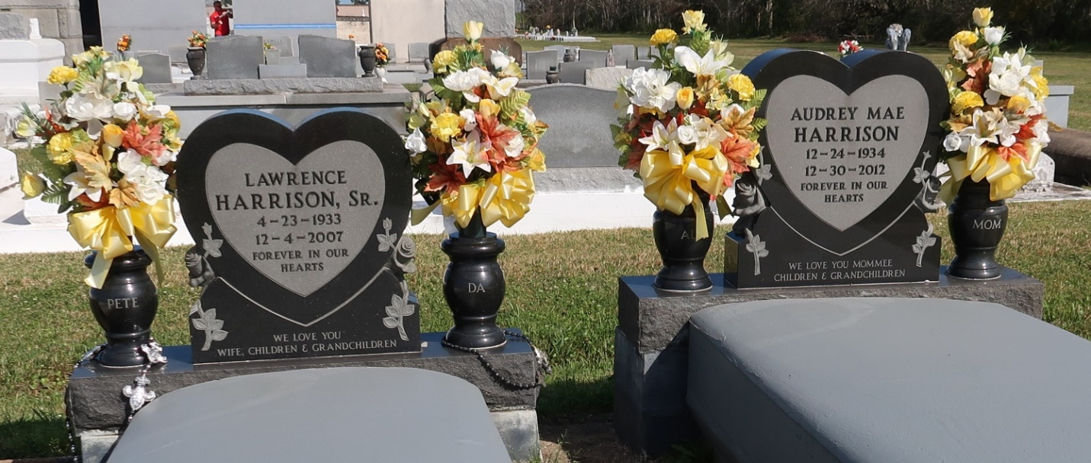

A retired shipfitter for Avondale Shipyard, he died Tuesday, Dec. 4, 2007, at Thibodaux Regional Medical Center. He was 74 and a native and resident of Vacherie.

Visiting at St. Phillip Catholic Church, Vacherie, on Tuesday, Dec. 11, from 8:30 a.m. until 10:50 a.m. Mass of Christian Burial at 11 a.m., the Rev. Louis Oubre, celebrant. Interment in the church cemetery.

He is survived by his wife, Audrey Dillon Harrison; six daughters, Debra Robinson, Angela Johnson, Darlene Narcisse, and Erica, Charlene and Tameka Harrison; five sons, Lawrence Jr., Mark, Craig, Antonio, Terrence and Harrison; two sisters, Ida H. Thompson and Nettie Woods; two brothers, Terrell and Raymond Harrison; 20 grandchildren, six great-grandchildren and six great-great-grandchildren. Preceded in death by his parents, Felicien and Adeline Harrison. Arrangements by Baloney Funeral Home, Garyville, (985) 535-2540.

Published by The Advocate (LA) on Dec. 10, 2007.