Edward George Haydel Sr.

July 10, 1871 – October 14, 1945

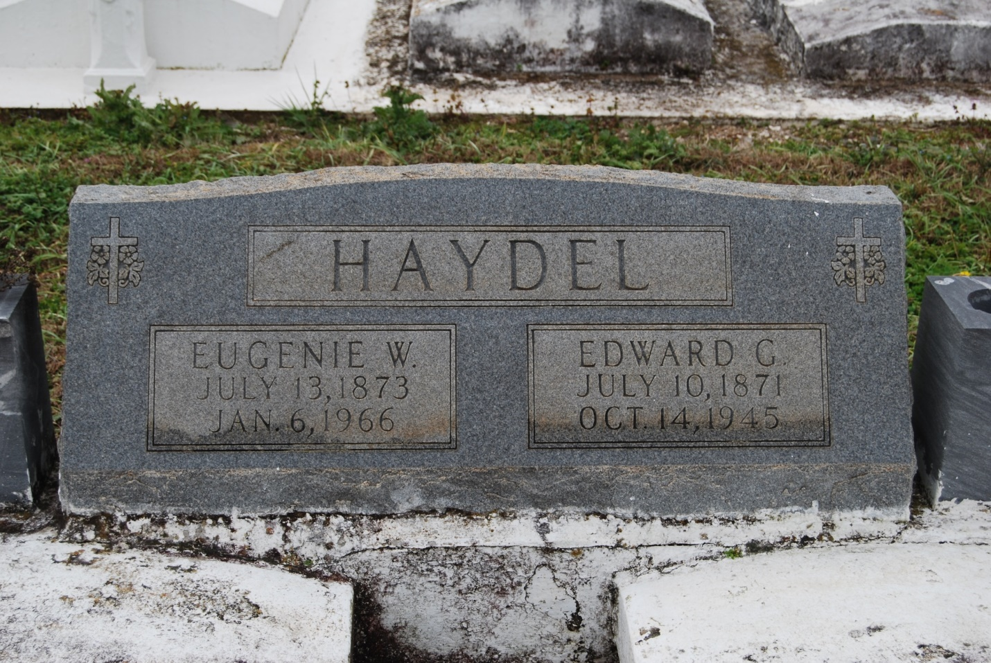

Photo by Kerry Keller

HAYDEL – of Vacherie, La., on Sunday, October 14, 1945, at 9:15 o’clock a.m. EDWARD HAYDEL, SR., beloved husband of Eugenie Waguespack, father of Mrs. Sylvere Luquette, Mrs. Lawrence Trosclair, Mrs. Edward Oubre, Jr., Mrs. Nemoure Loup, Mrs. Francis Madere, Mrs. George Fauchaux, Mrs. James Sutherland and Sister Mary Franceska, Froisin, Edward Jr., and George Haydel; a native of St. John parish, Louisiana, and a resident of St. James parish for 50 years; age 74 years.

Relatives and friends of the family are invited to attend the funeral which will take place from the daughter’s residence, Mrs. Fabien Trosclair, Vacherie, La., on Monday, October 15, 1945, at 8:30 o’clock a.m., followed by religious services at St. Philip church, Vacherie, LA., at 9 o’clock mass.

Interment in St. Philip cemetery. Millet funeral home, Reserve, La., in charge.

Times-Picayune, New Orleans, LA

Monday, October 15, 1945, p. 2