Marie Therese (Waguespack) Haydel

April 16, 1918 – December 26, 2004

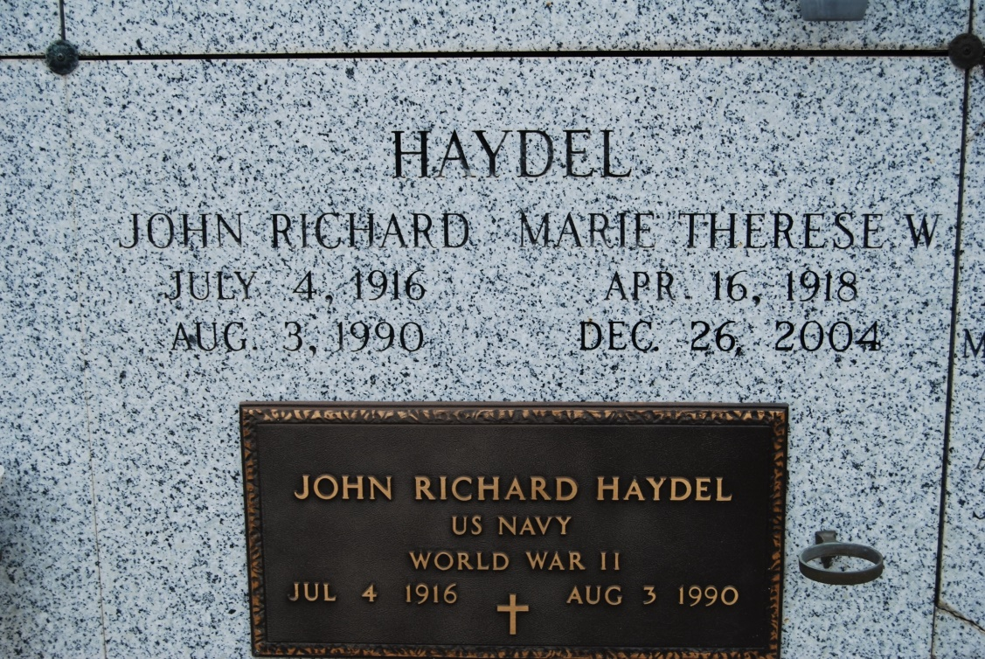

Photo by Kerry Keller

Marie Therese Waguespack Haydel died Sunday, Dec. 26, 2004, at 2:20 a.m. in New Orleans. She was 86 years old.  
 She was the wife of the late John Richard Haydel; mother and mother-in-law of John Richard Haydel Jr. and Susan M. Haydel of Mandeville and Glenda Haydel Folse and James Anthony Folse of Metairie; grandmother of Aimée Elizabeth Folse and Richard Fernand Folse; daughter of the late Berthe Schexnayder Waguespack and Fernand Etienne Waguespack; and sister of Nolan E. Waguespack of Vacherie, Arthur G. Waguespack and Nelson A. Waguespack of Lafayette, and the late Calvin F. Waguespack, Stanley A. Waguespack, Mark E. Waguespack and Fernand J. Waguespack.  
 She was a native of Vacherie and a resident of New Orleans.

Unknown source

\*\*\*\*\*

VACHERIE - Marie Therese Waguespack Haydel, 86, a native of Vacherie and resident of New Orleans, died Dec. 26. She was the wife of the late John Haydel, and mother of Glenda Folse and John Haydel Jr.  
 She was also the daughter of the late Fernand and Berthe Schexnayder Waguespack, and sister of Arthur and Nelson Waguespack, and the late Calvin, Stanley, Mark and Fernand Waguespack. She is also survived by two grandchildren.  
 Services are today at 11 a.m., at St. Philip Catholic Church, Vacherie, with interment at the church mausoleum. Visitation starts at 9 a.m.

L'Observateur (La Place, LA)

Thursday, December 30, 2004