Mildred (Brown) Hubbell

March 13, 1934 – May 26, 2011

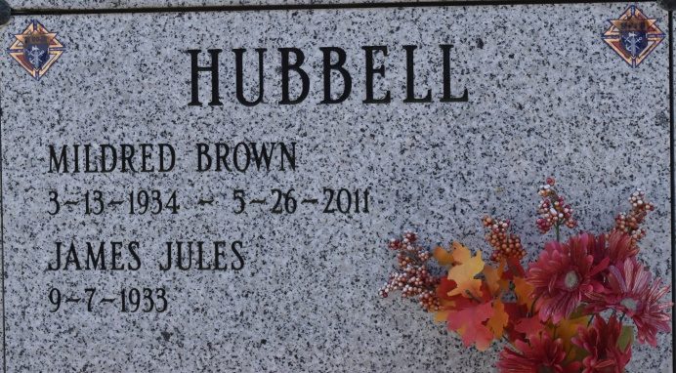

Mildred "Mickey" B. Hubbell, 77, a native of St. Charles Community near Thibodaux and resident of Napoleonville, died at 10:28 a.m. Thursday, May 26, 2011.  
 Visitation will be from 6 to 9 p.m. Sunday and from 9 a.m. to funeral time Monday at Landry's Funeral Home in Napoleonville. The Rosary of Our Lady will be offered at 10 a.m. Monday at the funeral home. Mass will be held at 11 a.m. Monday at St. Anne Catholic Church in Napoleonville, with private burial at a later date.  
 She is survived by her husband of 51 years, James J. Hubbell; four children, Thomas J. and wife, Mary, of Gramercy, Anne E. Hubbell of Birmingham, Ala., Lee P. Hubbell of Chicago, and Laurie and husband, Michael Wood, of Birmingham, Ala.; her grandchildren, Aaron and Emily Hubbell, Cecilia, Gabriel, and Patrick Wood; one brother, Warren Brown and wife, Eula of Pensacola, Fla.; her brother-in-law, Robert Talbot; two sisters-in-law, Esther Q. Brown and Ethlyn "Toot" Arabie Brown; and numerous nieces and nephews.  
 She was preceded in death by her parents, Henry Jack Brown and Sylvania Boudreaux Brown; two brothers, Perry and Wilbur Brown; two sisters, Henrietta Brown Reyer and Grace Brown Talbot; and her husband's parents, Philip and Cecile Hubbell.  
 She was a devoted Catholic, a daily communicant, and active member of St. Anne's Church Parish in Napoleonville. Her activities include: St. Anne Ladies' Altar Society, Our Lady of Lourdes Fraternity Third Order of Mary, CCD teacher and director, coordinator of the centering prayer groups and Eucharistic Minister. Also active with her husband, "Jimmy", as co-chairs in many activities of the Louisiana State Council of the Knights of Columbus, Bayou Right to Life, and a committed adorer at the Perpetual Adoration Chapel.  
 "Mickey" was a home economics graduate of SLI and taught home economics at Lockport High School. She was a talented seamstress and quilter. She enjoyed participating with the Magic Fingers Quilting Club of Napoleonville. She served as a volunteer at the "Helping Hands Thrift Store" since its inception and served for many years.  
 The family would like to thank all who offered their prayers, well wishes and assistance during her periods of illness. In lieu of flowers, please make a donation to the charity of your choosing. Landry's Funeral Home of Thibodaux is in charge of arrangements.

Published by Houma Today (LA) from May 28 to May 29, 2011.