Bradley Jean Hymel

February 16, 1989 – June 7, 2012

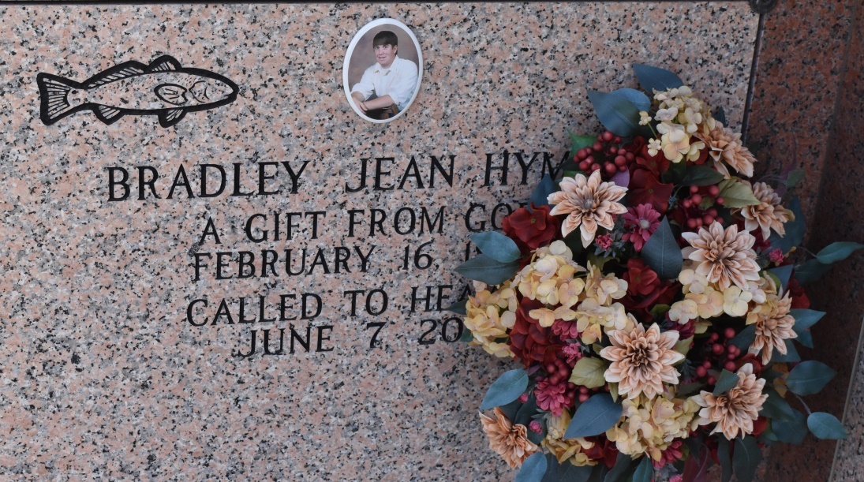

Bradley Jean Hymel, a native and resident of Vacherie, died peacefully in the presence of his mom and dad Thursday June 7, 2012 at the age of 23. He was a 2007 graduate of E.D. White High School and a former student of Nicholls State University. Brad's love of the outdoors, animals and especially his willingness to help others led his drive to one day be a nurse like his mom.  
 Visitation will be held Mon. from 8 am. until funeral mass of Christian burial at 11am. at St. Philip Catholic Church. Interment immediately following in St. Philip Church Mausoleum.  
 He is survived by his parents, Steven and Monica Steib Hymel, brothers, Matthew and Andrew Hymel, and grandparents, Clifton "Kippy" and Doris Hymel of St. James. He was preceded in death by Adolphe and Marie Steib.  
 Arrangements by Thibodaux Funeral Home.

Published by Houma Today (LA) from Jun. 9 to Jun. 10, 2012.