Junior Paul “Poorie” James

August 23, 1950 – December 4, 2012

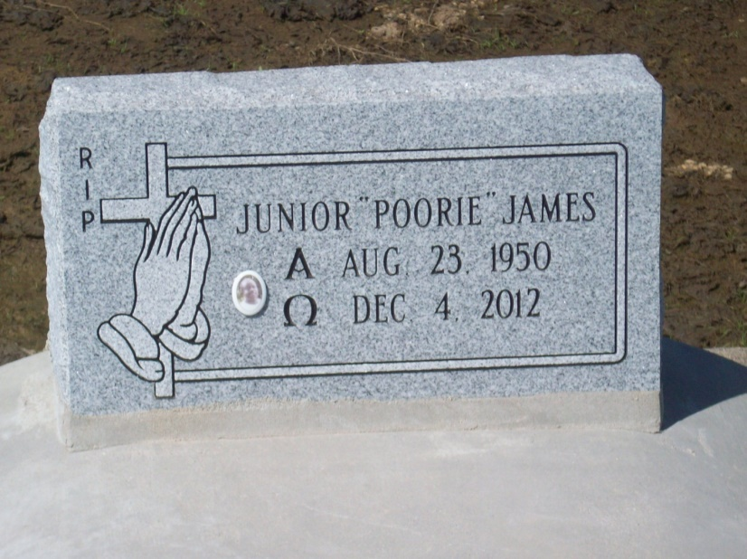

Photo by TMB

Junior Paul "Poorie" James: He entered into eternal rest peacefully on Tuesday, December 4, 2012 at AMG Speciality Hospital in Houma, LA. Devoted son of Louise James and the late Robert James. Loving father of Triane Lashai Blain, Christopher ( Bionka), and Andrew (La Kiva) Costley. Brother of Glenda Fletcher, Linda Johnson, Lois Harris (Larry), Vanessa, Tyrone, Rodney, and Yvette James, Angie Boden (Michael), Randy (Kimberly), and Dwayne James.

Unknown source

\*\*\*\*\*

Junior Paul James - A retired laborer, he died Tuesday, Dec. 4, 2012 at AMG Speciality Hospital in Houma, La. He was 62, a native and resident of Vacherie, La. Visiting on Monday, Dec. 10, 2012 from 7:30 a.m. to the Mass of Christian Burial at 10 a.m. at St. Phillip Catholic Church, Vacherie, La officiated by Rev. Chris Decker. Burial in the church cemetery. Arrangements by Williams & Southall Funeral Home, Napoleonville, La (985) 369-7231. To sign guest book or offer condolences, visit our web site at www.williamsandsouthallfuneralhome.com.

Advocate, The (Baton Rouge, LA) - Saturday, December 8, 2012