Doretha (Adams) Jasmin

September 24, 1917 – February 14, 2007

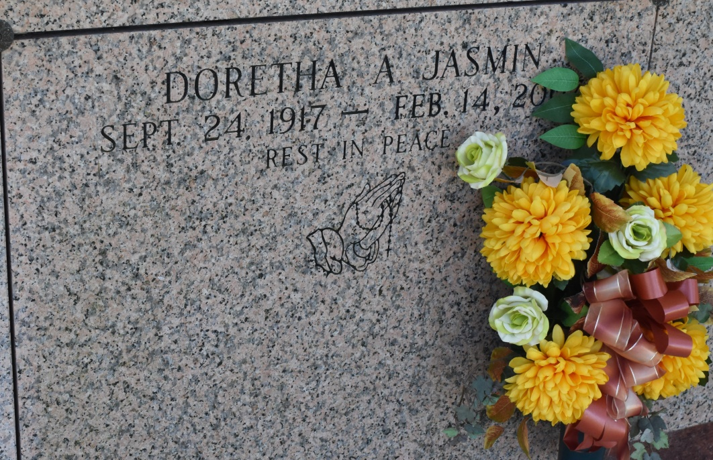

Doretha Adams Jasmin, of Vacherie, LA. departed this life on Wednesday, February 14, 2007 at 4:50 a.m. at Thibodaux Regional Medical Center.

Wife of the late Willie Jasmin. Daughter of the Ishmeal and Carrie Adams. Mother of Carrie Borne, Cheryl Williams, Brenda (Eliozy) Dumas, Norwood (Julia) Adams of Vacherie, LA. and the late Marvin and Willis Jasmin. Sister of Norwood (Neomi) Adams of Slidell, LA and the late Willetta A. Burris, Kilmer, Alcus and Haltron Adams. Also survived by 21 grandchildren, 28 great grandchldren, 3 great-great grandchildren, a host of nieces, nephews, cousins, and friends. Preceded in death by a grandchild Nia-Lynn Borne. A native and resident of Vacherie, LA. Age 89 years.

Relatives and friends of the family, also priest and parishioners of St. Phillip Catholic Church and neighboring churches are invited to attend A Mass of Christian Burial on Saturday, February 17, 2007 at 11:00 a.m. from the St. Phillip Catholic Church, 1175 Hwy. 18, Vacherie, LA. Father Louis Oubre, celebrant. Recitation of the rosary at 9:30 a.m. Visitation at the church after 9:00 a.m. Entombment church mausoleum. THE BALONEY FUNERAL HOME, L.L.C. 399 Earl Baloney Dr. Garyville, LA 70051 985-535-2540 In charge of arrangements

Published by The Times-Picayune (LA) on Feb. 16, 2007.