Leroy Paul Jeffery

June 3, 1939 – February 13, 2021

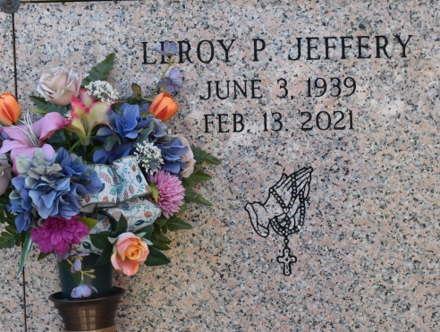

Leroy Paul Jeffery began his life on June 3, 1939. He was the fifth of six children born to Bernard and Elvonia Oubre-Jeffery. He was the devoted husband of Eula Stevens Jeffery. This union brought forth two children, Terrence and Michelle Jeffery. He departed this life on February 13, 2021.  
 Leroy was a construction worker and truck driver. He worked in and around the Vacherie area for many years. Sometimes he commuted back and forth out of town for construction work. Leroy’s hobbies were gardening, fishing, hunting and making wine that he never drank. He especially liked gardening. Many times, he would give his sisters, neighbors, and friends some of his vegetables. If he would catch any fish, he would give most of those away. If he brought back any rabbits from hunting, he would give all those away. He also liked football games. His favorite team was the Saints. Prior to his death, he wasn’t able to do much because of his declining health. But with the help of his brother Roland and his close friend, Reginald Borne, he was able to have a small garden.  
 Leroy leaves to cherish his memory, his wife, Eula Jeffery; son, Terrence; four grandchildren, Brittany Holmes(Standish Holmes), Terrence Jr., Jillisa, and James Jeffery; five great grandchildren, Kameryn, Standish II, Jace, Jordyn and Xavier; two sisters, Ordean Joseph and Cleo Batiste; one brother, Roland Jeffery; a brother-in-law, Raymond Batiste; two sisters-in-law, Glendora Jeffery and Marie Jeffery, a brother and sister-in-law Anthony and Joyce Stevens, and a host of nephews, nieces and cousins, other relatives and friends.  
 Leroy was preceded in death by his father and mother Bernard and Elvonia Oubre-Jeffery, a daughter Michelle Jeffery, two brothers Bernard Jeffery Jr. and Cantrelle Jeffery Sr., one brother-in-law Sidney Joseph and one sister-in-law Gladys Jeffery.  
 A public walk-through visitation will be held on Friday, February 19, 2021 from 4pm-6pm at Treasures of Life Funeral Services, 315 E Airline Hwy, Gramercy, LA 70052. A mass of Christian burial will be held on Saturday, February 20, 2021 at St. Philip Catholic Church, 1175 LA-18, Vacherie, LA 70090. Rosary at 10:35am. Service will begin at 11am. Entombment to follow at St. Philip Catholic Church Cemetery.

Final care entrusted to Treasures of Life Funeral Services. Due to CDC (COVID-19) guidelines and restrictions, masks and social distancing are REQUIRED!

Treasures of Life Funeral Services, Gramercy, Louisiana