Lorenza Ann (Etienne) Joseph

December 17, 1953 – May 12, 2015

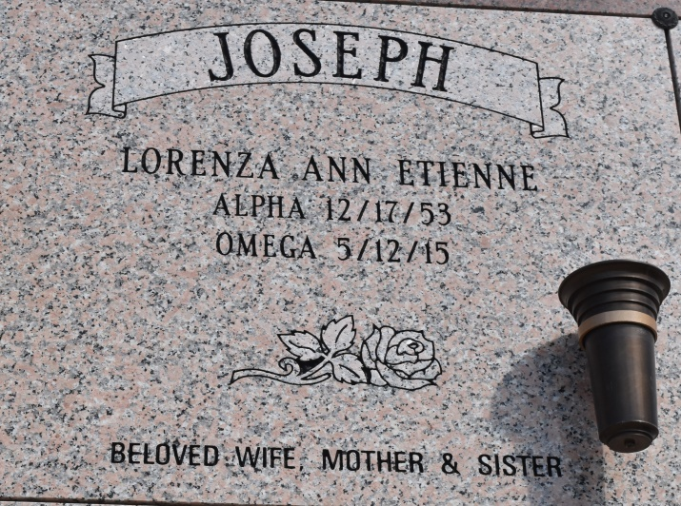

Lorenza Ann Etienne Joseph, a native and resident of Vacherie, LA, age 61 on Tuesday, May 12, 2015 at her residence. Daughter of the late Irvin & Mildred Noel Etienne. Beloved wife of Thomas Joseph. Beloved mother of Kelsey Joseph. Survived by siblings, Mary Stewart, Rita Johnson, Brenda Trench, Linda Rixner, Faye Hooker, Mildred M. Etienne, Vondra Steib and August Etienne. Also survived by a host of nieces, nephews, brother-in-laws, other relatives and friends.

Relatives and friends of the family, also pastor, officers and members of First Baptist Church, Star of Bethel B.C-New Orleans and neighboring churches are invited to attend the funeral services on Friday, May 15, 2015 at 11:00am at First Baptist Church 1244 Magnolia Heights, Vacherie, LA. Rev. Johnnie Mcgee, officiating. Visitation at the church at 9:00am on Friday. Entombment St. Phillip Catholic Church Mausoleum, Vacherie, LA. Treasures of Life Center for Life Funeral Services. 315 E. Airline Hwy., Gramercy, La 70052

Published by The Times-Picayune from May 12 to May 13, 2015.