Tramiya Michelle Marie Keller
October 7, 2000 – May 9, 2024

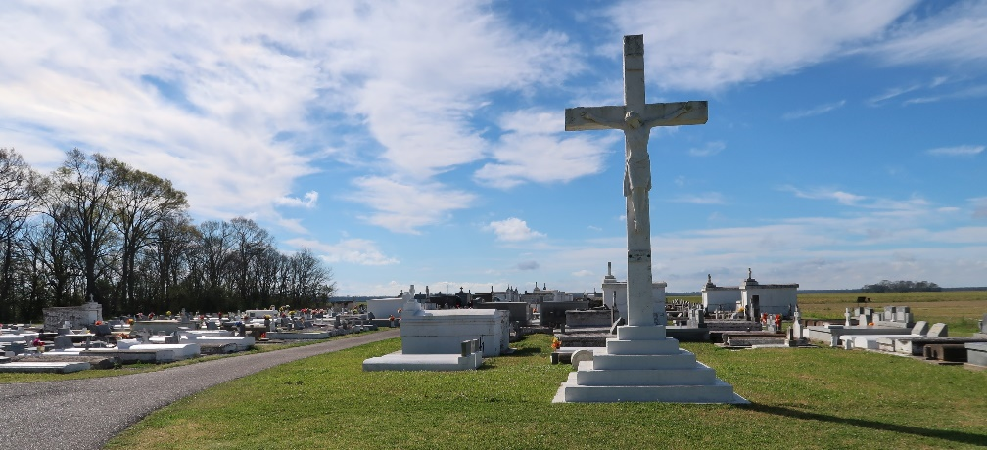

Tramiya Michelle Marie Keller transitioned from her earthly life on May 9, 2024, at her home in Laplace, LA at the age of 23. Tramiya was born on October 7, 2000, to Heather Edwards and the late Troy M. Keller. She enjoyed taking weekend trips and spending time with her son and close family and friends. Miya was a hands on mom that loved taking her son to the park and bringing him snowballs and McDonald's (his favorite). She loved her lashes and wigs, which she took pride in making and installing herself. Miya was a beautiful person with a lovely smile that will truly be missed and forever loved.
Tramiya leaves behind her precious memories that will forever be cherished by her son: Bryden Faulk; mother: Heather Edwards; brother: Razan Keller; bonus sister, Janae Young; 3 bonus nieces; companion: Kenneth Mitchell; devoted friends: Chesarae Thomas and Ty Gross; Godchild: Brennan Stevens, Jr.; maternal grandparents: Darlene and Landry Borne, and David Dee; paternal grandparent: Odette Keller; and a host of aunts, uncles, other relatives and friends.
Tramiya was preceded in death by her father: Troy M. Keller; paternal grandfather: Edward Keller, Sr.; and uncle: Izel Dee.
"Your wings were ready, but our hearts were not." A Mass of Christian Burial will be held on Friday, May 24, 2024, at Our Lady of the Holy Rosary Catholic Church, 1 Rectory Ln, Hahnville, LA 70057. Visitation beginning at 9AM with Mass to follow at 11AM. Interment at St. Philip Catholic Church Cemetery in Vacherie, LA.

Treasures of Life Funeral Services, Gramercy, LA 70052
May 21, 2024

