Milton “Mitch” Kliebert

December 30, 1940 – November 22, 2010

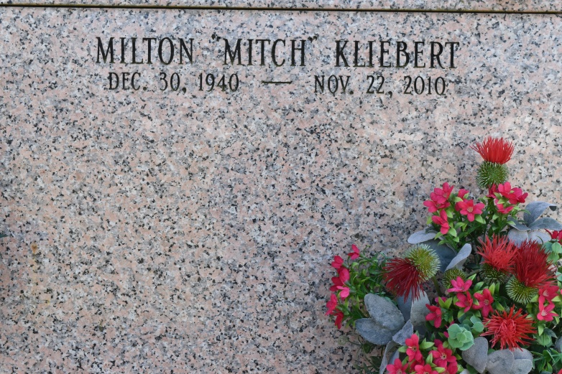

Milton "Mitch" Kliebert passed away, at the age of 69, on Monday, November 22, 2010. Born December 30, 1940 in St. James, LA. Beloved husband of Alice Coleman Kliebert. Father of Michael James Kliebert of Raceland, LA and Melissa "Missy" Kliebert Granier of Chackbay, LA. Father-in-law of Ella Douglas Kliebert and Denis Granier. Loving and devoted grandfather of Olivia, and Michael James Kliebert II, Bobby and Bradley, and John Granier. Brother of Mary Ann Kliebert Laurent of Metairie, LA, Amelia Kliebert Morvant and Therese Kliebert Flose of Vacherie, LA and Remie Kliebert of LaCombe, LA. Son of the late Hubert and Althea Webre Kliebert of Vacherie, LA. He will be missed by all those lives he touched.

He served 8 years in the Louisiana National Guard, member of St. James Fire Association and was president of the North Vacherie Volunteer Fire Department for 25 years. He was employed by Fabco Inc., St. James, LA for 36 years and contracted maintenance work to LoCap, St. James, LA for 18 years. He loved camping and fishing with his friends. He was cremated at Ourso Funeral Home.

A Memorial Mass will be held at St. Philip Catholic Church at a later date. In lieu of flowers, please donate to the American Cancer Soceity. To offer condolences, please visit [www.oursofh.com](http://www.oursofh.com/)

Published by The Times-Picayune (LA) on Nov. 23, 2010.