Emelie Aurelia (Roussel) Loup

December 2, 1880 – April 17, 1955

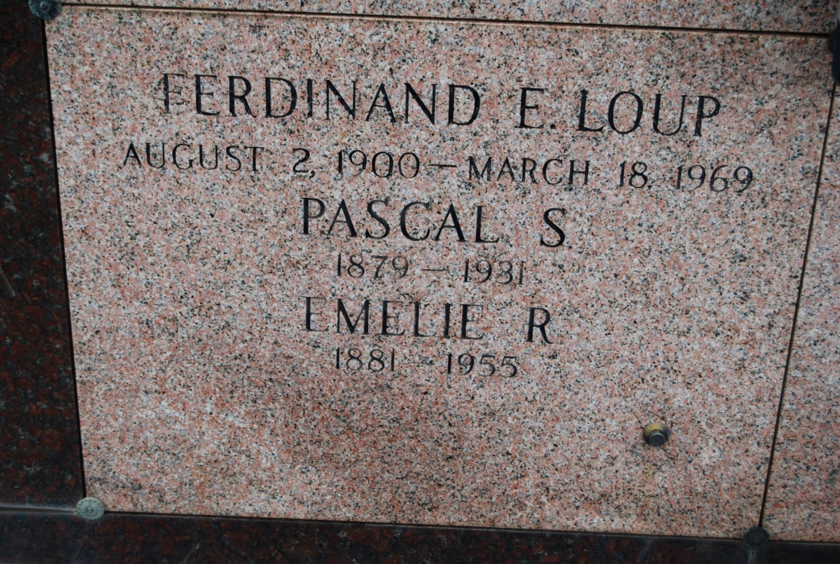

Photo by Kerry Keller

LOUP – At her late residence, Wallace, La., on Sunday, April 17, 1955, at 11:50 o’clock a.m. EMELIE ROUSSEL, wife of the late Pascal Loup/ mother of Nemour and Felicien Loup, Mrs. Henry J. Burch Jr. of Wallace, La., Ferdinand Loup of New Orleans, La., Mrs. Joseph Bienodello of Baton Rouge, La., Mrs. Laurent Waguespack of Vacherie, La., Mrs. Jules Hymel of St. James, La., and Roy Loup of Sulphur, La.; also survived by 31 grandchildren, seven great-grandchildren; aged 74 years; a native of Vacherie, La., and a resident of Wallace, La., for 40 years.

Relatives and friends of the family are invited to attend the funeral which will take place from her late residence in Wallace, La., on Tuesday, April 19, 1955, at 9 o’clock a.m., followed by solemn requiem high mass at St. Philip church, Vacherie, LA. Interment in St. Philip cemetery, Vacherie, La. Arrangements by Alexander funeral home.

Times-Picayune, New Orleans, LA

Tuesday, April 19, 1955