Eveline Marie Loup

January 24, 1899 – October 18, 1970

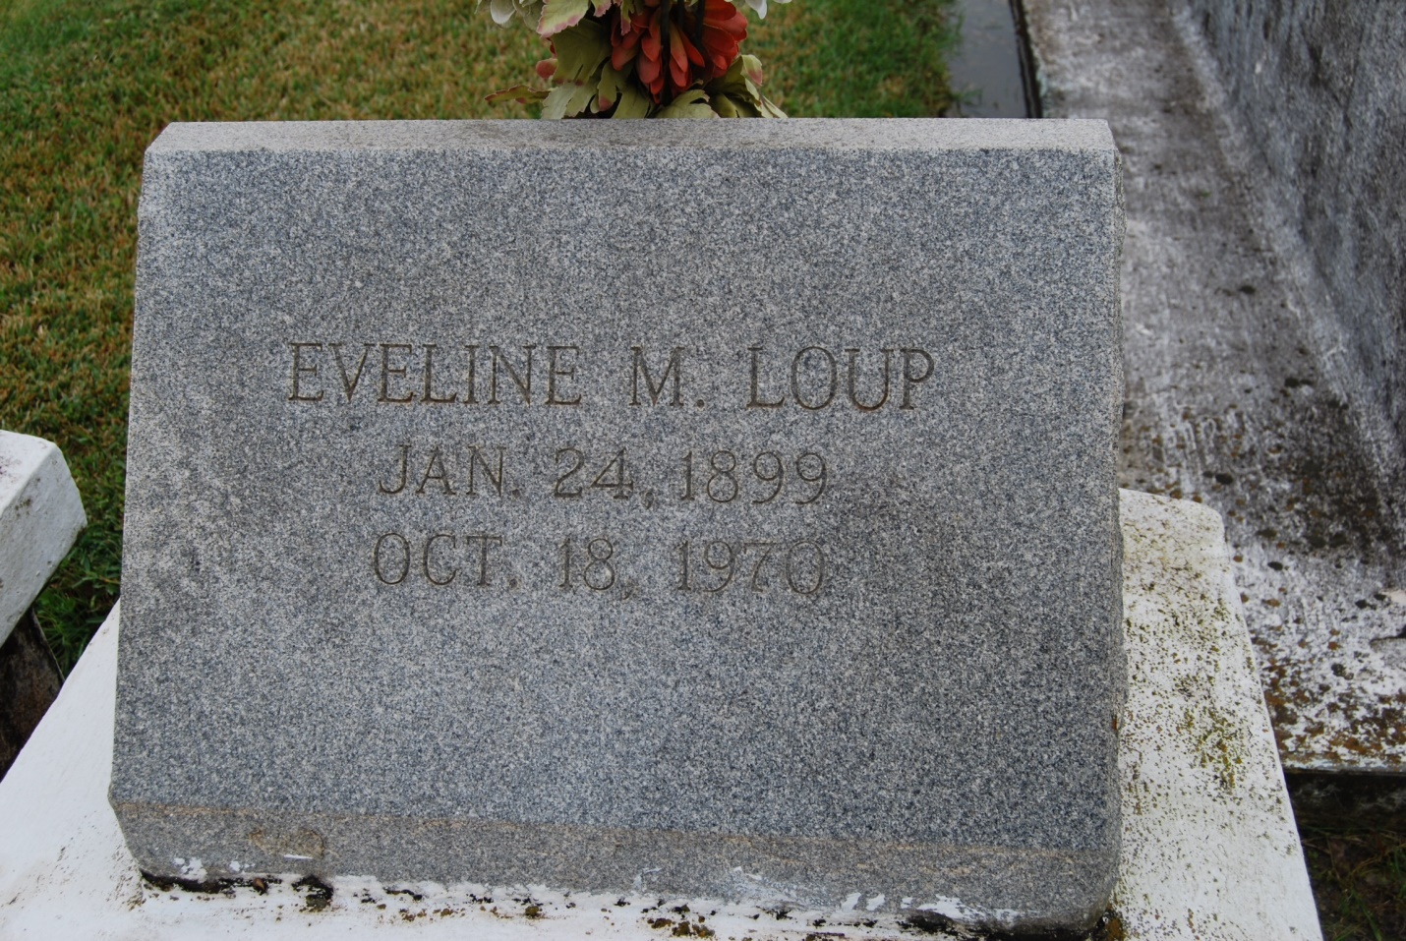

Photo by Kerry Keller

LOUP – Miss Eveline Marie Loup on Sunday, October 18, 1970, at 6:15 o’clock p.m., daughter of the late Cleomen J. Loup and Elia Zeringue Loup; sister of Mrs. Stella Theriot of New Orleans, La., Jean Loup of Vacherie, La., Mrs. Louise Breaud and Maurice Loup, both of Lulling, La., and of the late Louis Loup; age 71 years; a native and a resident of Vacherie, La.

Relatives and friends of the family are invited to attend the funeral. Services from the Knights of Columbus Home, Vacherie, La., on Tuesday, October 20, 1970, at 10:45 o’clock a.m., religious services at St. Philip’s Church, Vacherie, La., at 11 a.m. Interment in the church cemetery. Friends may call after 4 p.m., Monday. Arrangements by Alexander Funeral Home.

Times-Picayune, New Orleans, LA

Monday morning, October 19, 1970, p. 16