Felician Joseph Loup, Sr.

June 8, 1902 – June 29, 1984

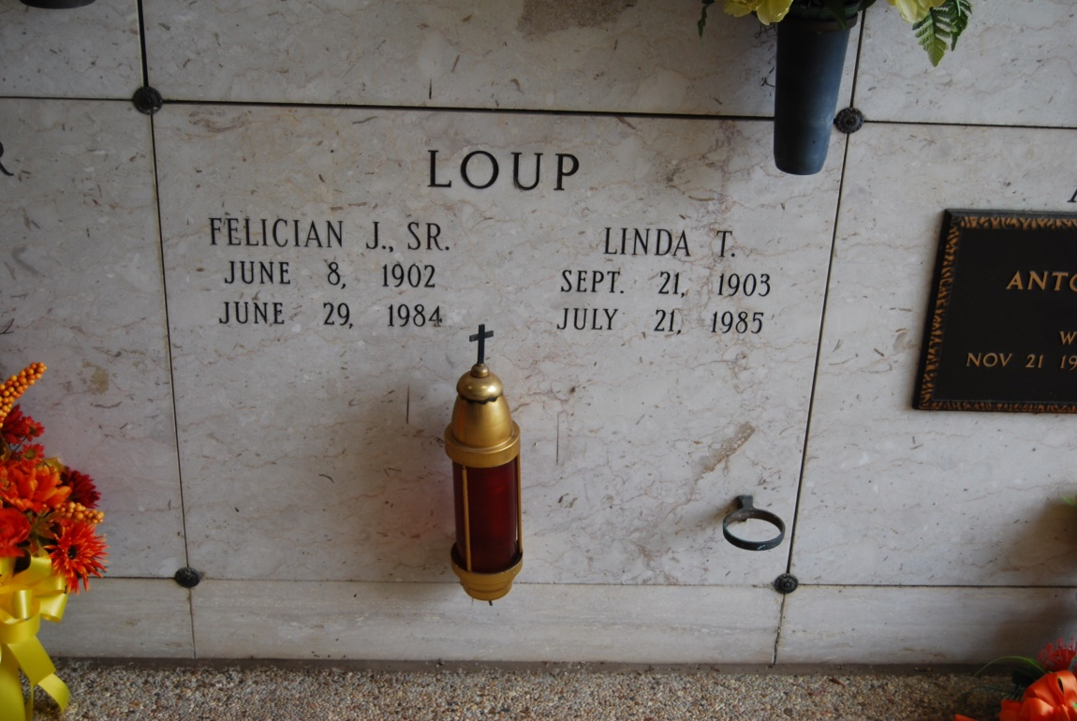

Photo by Kerry Keller

LOUP, Felician J. Sr. – Died 3:40 p.m. Friday, June 29, 1984, in Thibodaux. He was 82, a native of Wallace and resident of Vacherie. He was a retired Colonial Sugars of Gramercy foreman, with 42 years services. Visiting at St. Philip Catholic Church, Vacherie, 8 a.m. to religious services at 11 a.m. Monday, conducted by Father Salvadore Moran. Burial in church cemetery. Survived by wife, Linda Tregre Loup, Vachherie; four daughters, mrs. Earl (Annabel) Lambert, Metairie, Mrs. Henry (Ruby) Roussel, Avondale, Mrs. Richard (Shirley) Schexnayder, and Mrs. Myles (Linda) Chauvin, both of Vacherie; four sons, F. J. Loup Jr., Vacherie, Leroy Loup, Luling, Curtis Loup, LaPlace, and Gene Loup, Houston; three sisters, Mrs. Joe (Velma) Biondella, Baton Rouge, Mrs. Laurent (Clemance) Waguespack Sr., Vacherie, and Mrs. Henry (Louella) Burch, Vacherie; a brother, Roy Loup, Lake Charles; 25 grandchildren; 11 great-grandchildren. Preced in death by parents, Pascal and Emily Roussel Loup; two brothers, Ferdinand and Nemour Loup; and a sister, Lucella Hymel.

Sunday Advocate, Baton Rouge, LA

Wednesday, March 19, 1969, p. 8-A