Henry Benjamin Loup, Sr.

February 26, 1881 – June 9, 1961

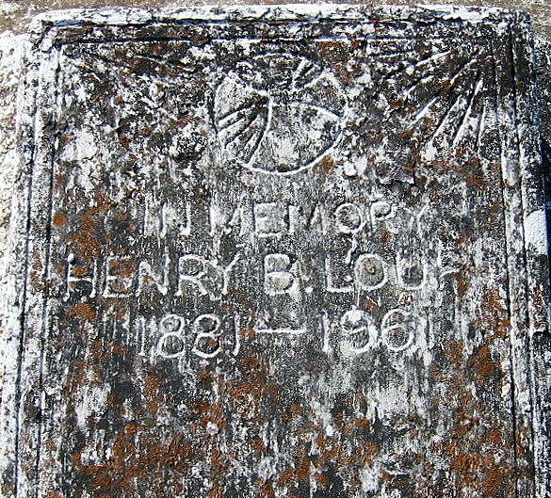

Photo by Bobby

LOUP – On Friday, June 9, 1961, at 6:30 o’clock a.m. HENRY B. LOUP SR., beloved husband of Olive Marie Bellow; father of Henry B. Loup Jr., Mrs. Howard Daigle, Mrs. Joseph LeBlanc, Mrs. Joseph Woods, Mrs. Lessie Scioneaux, Mrs. Earl Deibel, Mrs. John Freeman, Lloyd, Lawrence and Eugene Loup; brother of John Loup and the late Pascal and Pitrie Loup, also survived by 37 grandchildren and 7 great-grandchildren; aged 79 years; a native of St. James parish, and a resident of Gretna, La., for 45 years.

Relatives and friends of the family, also board of commissioners, Port of New Orleans, Public Grain Elevator, T. Smith and Son and Avondale Shipyard, are invited to attend the funeral. Services from the Gretna home of Leitz-Eagan, 919 Amelia avenue on Saturday morning, June 10, 1961, at 9 o’clock. Religious services at 11 o’clock a.m. at St. Philip’s church, Vacherie, La. Interment in St. Philip cemetery, Vacherie, La.

Times-Picayune, New Orleans, LA

Saturday, June 10, 1961, p. 3