Jean Cleomen Loup, Jr.

September 22, 1913 – November 29, 1977

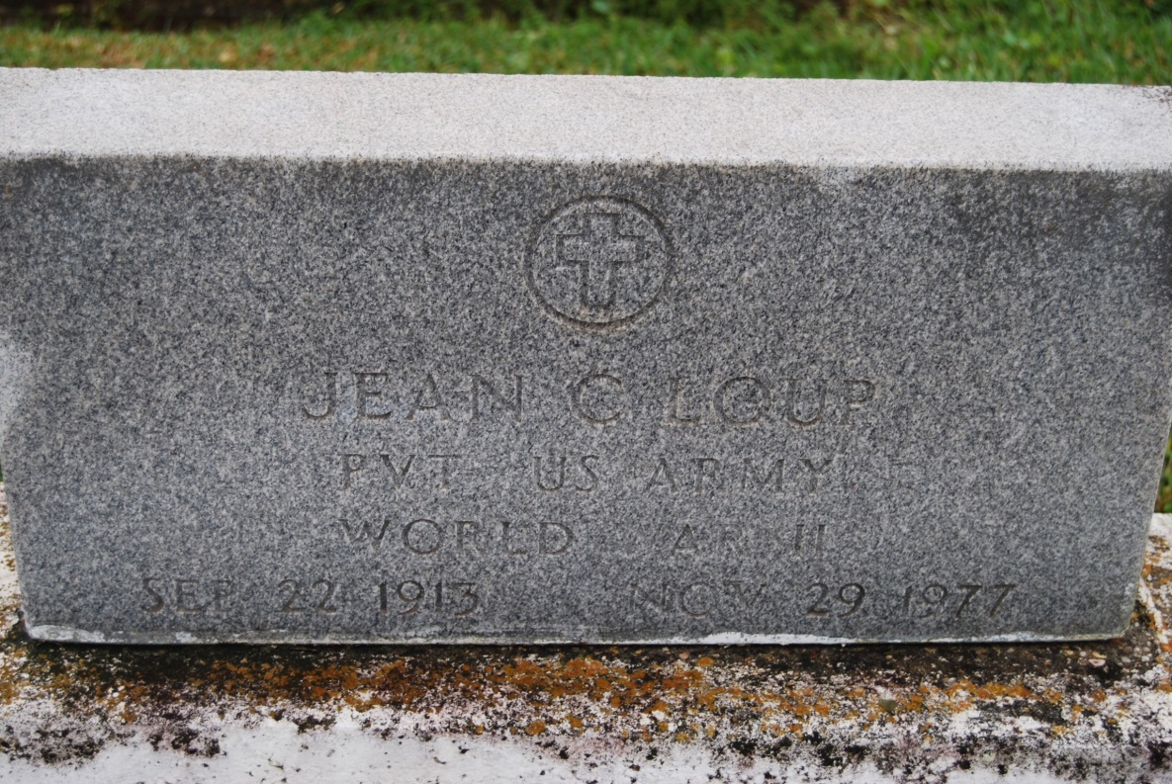

Photo by Kerry Keller

LOUP, JEAN C. – Died at 4 a.m. Tuesday, Nov. 29, 1977, at West St. James Parish Hospital, Vacherie. He was 64, a native and resident of Vacherie. He was retired from Colonial Sugar Co. Body at St. Philip Parish Hall, Vacherie, with visiting from 8 a.m. until funeral time. Religious services at St. Philip’s Catholic Church, Vacherie, at 10 a.m. Wednesday. Burial in the church cemetery.

Survived by his wife, Mrs. Virgie Rodrigue Loup; two daughters, Mrs. Joseph (Linda) Rousseau, Vacherie, and Miss Mary Loup, New Orleans; one sister, Stella Theriot, New Orleans; one brother, Maurice Loup, Luling; two granddaughters. Preceded in death by his parents, Cleomen J. Loup & Elia C. Loup; two sisters, Eveline Loup and Louise Breaux, and a brother, Louis Loup Sr. Alexander Funeral Home, Lutcher, in charge of arrangements.

Morning Advocate, Baton Rouge, LA

Wednesday, November 30, 1977, p. 4-A