Leonie (Haydel) Loup

September 17, 1904 – November 27, 1993

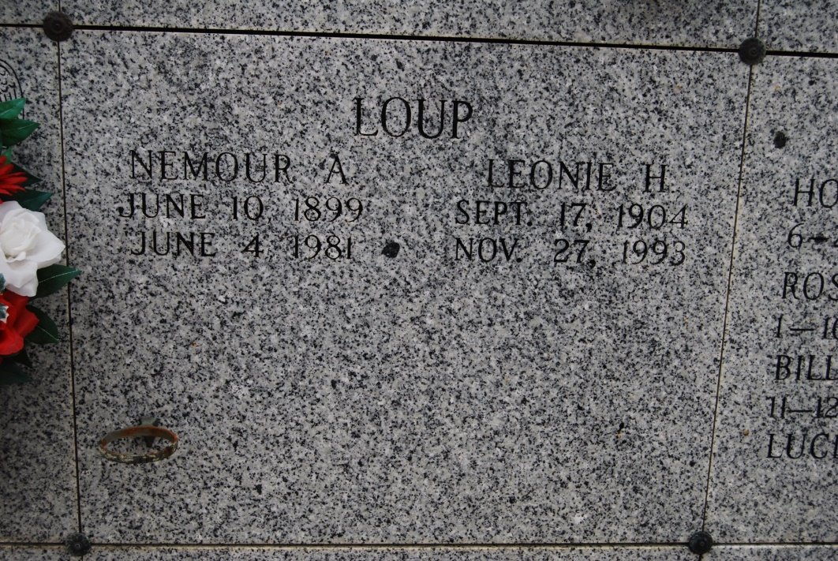

Photo by Kerry Keller

LOUP, LEONIE HYDEL (sic – Haydel)

Died Saturday, Nov. 27, 1993, at her residence in Vacherie. She was a native of Vacherie. Visiting at St. Philip Catholic Church, Vacherie, 8 a.m. until Mass of Christian Burial at noon Monday, conducted by Father Butch Moran. Entombment in St. Philip Mausoleum.

Survived by four daughters, Doris Giarrusso, new Orleans, Winona Mathew, Missouri, Joyce Rodrigue, Donaldsonville, and Myrna Steib, Luling; two sons, Percy Loup, New Mexico, and Clarence Loup, Wallace; two sisters, Stella Sutherland, Baton Rouge, and Denise Madere, Reserve; 13 grandchildren; and 13 great-grandchildren. Preceded in death by husband, Nemour Loup; three brothers and five sisters. Alexander Funeral Home, Lutcher, in charge of arrangements.

Advocate, Baton Rouge, LA

Monday, November 29, 1993, p.6-A; S