Linda (Tregre) Loup

September 21, 1903 – July 21, 1985

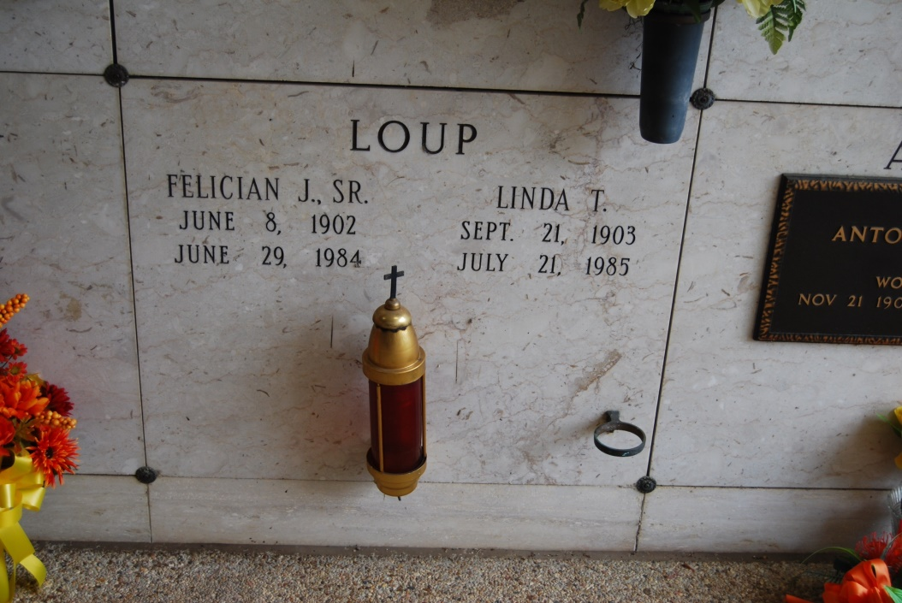

Photo by Kerry Keller

LOUP, LINDA TREGRE

Died Sunday, July 21, 1985, at 9:18 p.m. in Metairie. She was 81, a native and resident of Wallace. Visiting at Knights of Columus Hall, Vacherie, 8 to 11:45 a.m. Tuesday. Mass of Christian Burial at St. Philip Catholic Church, Vacherie, at noon Tuesday, conducted by the Rev. Salvadore Moran. Entombment in church mausoleum.

Survived by four daughters, Mrs. Earl (Annabel) Lambert, Metairie, Mrs. Henry (Ruby) Roussel, Avondale, Mrs. Richard (Shirley) Schexnayder and Mrs. Myles (Linda) Chauvin, both of Vacherie; four sons, F. J. Loup Jr., Vacherie, Leroy Loup, Luling, Curtis Loup, Laplace, and Gene Loup, Houston, Texas; two sisters, Mrs. Fergus (Noelie) Faucheux, Wallace, and Mrs. Zim Poirrier Schexnayder, Donaldsonville; 25 grandchildren and 11 great-grandchildren. Preceded in death by husband, Felicien Loup; parents, Felix and Zulma Tassin Tregre; a sister, Mrs. Leo (Martha) Poirrier; and a brother, Florian Tregre.

Morning Advocate, Baton Rouge, LA

Tuesday, July 23, 1985, p. 12-A