Marie Dervina (Aubert) Loup

September 5, 1880 – October 12, 1958

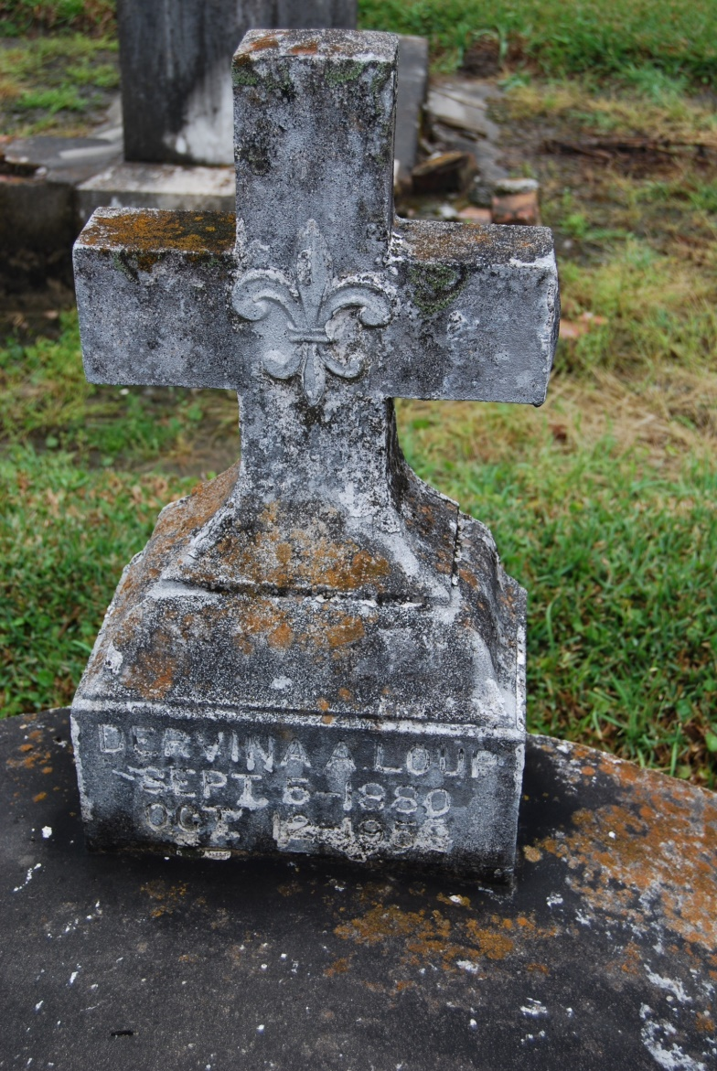

Photo by Kerry Keller

LOUP – At her residence, Wallace, La., on Sunday, October 12, 1958, at i:35 o’clock p.m., MARIE AUBERT, beloved wife of John Loup, mother of Marie Loup; age 78 years; a native and a resident of Wallace, La.

Relatives and friends of the family, also officers and members of the St. Philip Altar Society are invited to attend the funeral which will take place from the late residence, Wallace, La., on Tuesday, October 14, 1958, at 9 o’clock a.am. Religious services at St. Philip’s church, Vacherie, La. Interment in St. Philip’s cemetery, Vacherie. Arrangements by Alexander’s Funeral Home, Lutcher, La.

Times-Picayune, New Orleans, LA

Tuesday, October 14, 1958, p. 2