Nemour Antoine Loup

June 10, 1899 – June 4, 1981

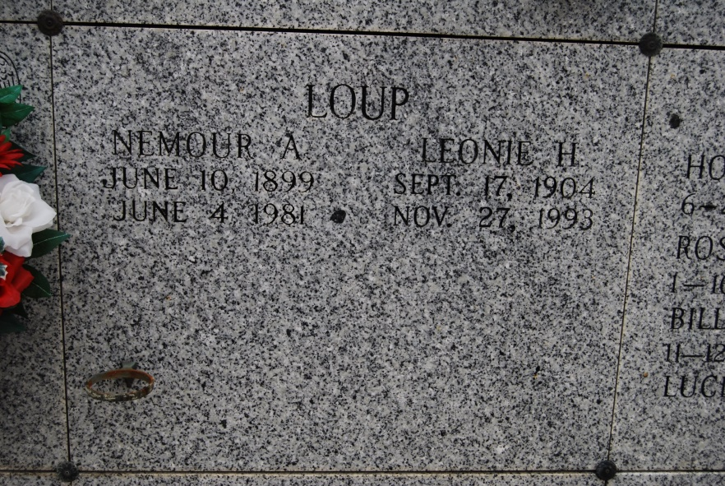

Photo by Kerry Keller

LOUP – Nemour A. Loup, at West St. James hospital, Vacherie, La., on Thursday, June 4, 1981, at 11:05 a.m., beloved husband of Leonie Haydel Loup, father of Mrs. Joyce Rodrigue of Donaldsonville, La., Mrs. Winnona Matthews of St. Louis, Mo., Mrs. Doris Gulorrusso of New Orleans, Mrs. Myrna Steib of Lulling, Clarence Loup of Wallace, Percy Loup of New Mexico; brother of Mrs. Velma Dionello of Baton Rouge, Roy Loup of Sulphur, La., Mrs. Luella Burch, Mrs. Clemence Waguespack, both of Vacherie, Felician Loup of Wallace, and the late Ferdinand Loup, and Mrs. Lucella Hymel; son of the late Pascal Loup and Emilie Roussel; also survived by 13 grandchildren, and 6 great-grandchildren, age 81 years, a native and resident of Wallace, LA.

Relatives and friends of the family are invited to attend the wake and funeral at St. Philip Catholic Church, Vacherie, La., on Saturday, June 6, 1981 at 10:30 a.m. Entombment in the Church Mausoleum. Visitation Saturday from 8 a.m. until funeral time. Arrangements by Cabellere Funeral Home, Donaldsonville, LA.

Times-Picayune, States-Item, New Orleans, LA

Saturday, June 6, 1981, p. 23