James Malacon, Sr.

July 28, 1939 – August 1, 2010

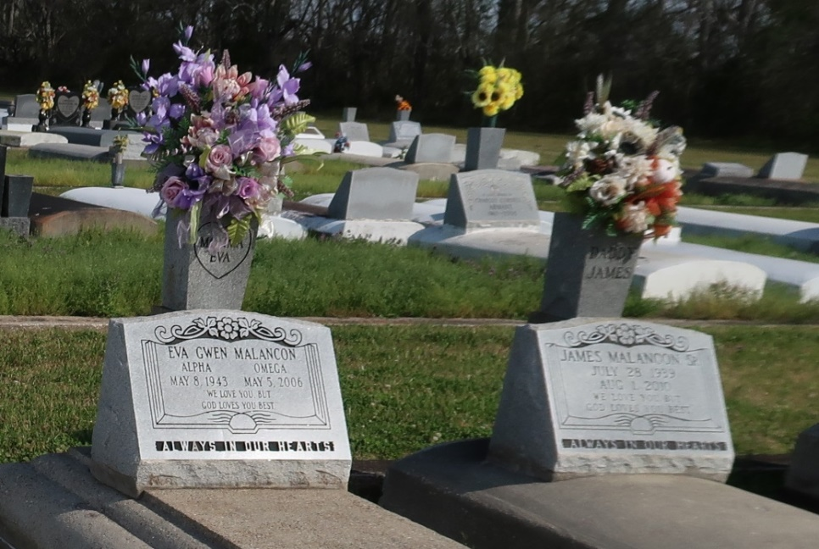

James Malancon Sr. of Vacherie, La. on Sun., Aug. 1, 2010 at his residence, departed this life. Husband of the late Eva Gwen Collins Malancon. Son of the late Joseph and Flavia N. Malancon. Father of James Jr. (Denise), Rydell (Yvette), Tammy (Richard), Romero, Ryan and Donnovan (Monique), all of Vacherie, La. Brother of Florence Roussell, Stella Castle (Curtis), Roy, Raymond, Larry (Linda), Steve (Debra), Roland (Josephine), Glenn (Shelia), Clinton (Rita), Barry (Verlyn), and the late Joseph Jr. Brother-in-law of Julius Collins Sr. (Laura) and Barbara Gibson (Charles). Also survived by 13 grandchildren and 2 great-grandchildren. Nephew of Henry Malancon Jr. and Eva Lois Hall. Devoted uncle of Cynthia Malancon. Also survived by a host of nieces, nephews, cousins and friends. A native and resident of Vacherie, La. Age 71 years.

A Mass of Christian Burial will be held on Thurs., Aug. 5, 2010 at 11:00 AM from the St. Phillip Catholic Church, 1175 Hwy. 18, Vacherie, La. Father Louis Oubre, Celebrant. Father Chris Decker, Pastor. Interment church cemetery. Visitation at the church after 9:00 AM. The Baloney Funeral Home LLC 399 Earl Baloney Dr., Garyville, La. 985-535-2540 In Charge of Arrangements

Published by The Times-Picayune, New Orleans, LA on Aug. 4, 2010.