Ryan Paul Malancon
August 29, 1966 – July 16, 2023

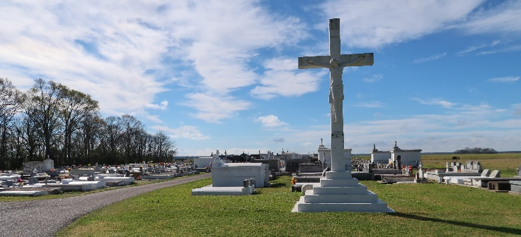

Ryan Paul Malancon "Moogie" was born on August 29, 1966, to the late James Malancon Sr. and the late Eva Gwen Collins Malancon. On July 16, 2023, Uncle Paul went to be with his heavenly father. He joined his earthly parents in a place free from pain, tears, and worries. He was baptized and confirmed at St. Philip Catholic Church.
Ryan attended St. James High School where he played football and was an outstanding middle linebacker, No.36. He really thought he knew everything. If he called everyone had better answer the phone. He graduated in 1985 and went on to study at Nichols State University. He went on to work for ABCL. Later in life his health began to fail.
Ryan was most known to everyone as "Uncle Paul" but to his friends, Moogie or Ranbo. His heart was so big there was room for everyone. His nieces and nephews were the twinkle in his eyes. His heart especially skipped a beat for Lulay (Aliyah) and Big Baby (Meia).
Uncle Paul leaves to cherish his memories, his only sister Tammy (Richard) Oubre (his Marie). His brothers: James (Denise), Rydell (Yvette), Romero Sr., and baby brother Donnavon (Monique) Malancon. Uncles: Larry (Linda), Steve (Debra) Malancon, and Curtis Castle. Aunts: Eva Mae Malancon Hall, Barbara and Laura Collins, Florence Roussell, and Josephine and Rita Malancon. His nieces: Karanique (Ashanti), Devin, BreAnna, Brittany, Aliyah, Rae'Shaun, Meia, C'Naj, Branai, Baleigh, Camlia, and Rhilyn. His nephews: Clydell Jr, Ty, Romero Jr, DeVaughn, Rydell Jr, Kase, and Malakai James. God children: Brittany Washington and Rachelle Mitchelle, and childhood sweetheart, wife, forever friend, Seimone Octave.
A Mass of Christian burial in honor of Ryan Paul Malancon will be held Friday, July 21, 2023 at St. Philip Catholic Church, 1175 LA-18, Vacherie, LA 70090. Visitation will begin at 10 am. Mass begins at 11 am. Interment to follow at St. Philip Catholic Church Cemetery, 1175 LA-18, Vacherie, LA 70090.

Treasures of Life Funeral Services, Gramercy, Louisiana
July 31, 2023

