Claudette A. (Cayette) Octave

About 1940 – March 19, 2021

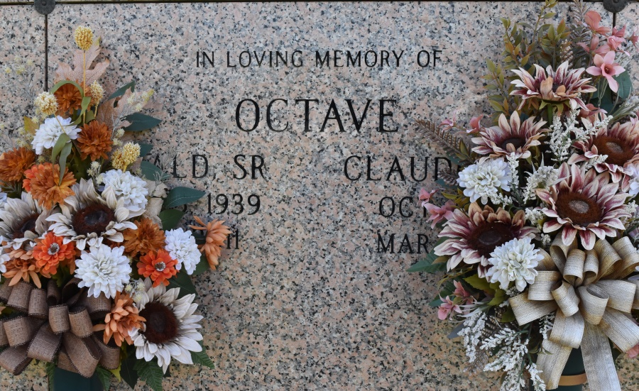

Claudette A. Cayette Octave, a native of Wallace, LA, departed this life surrounded by children and grandchildren on Friday, March 19, 2021 at the age of 81. Daughter of the late Hattie Chiquet and Ernest Cayette. Beloved wife of the late Ronald Octave Sr., mother of the late Ronald Jr., the late Darwin, Shelley, Seimon, Thaddeus and Shane Octave, sister of Lorraine Mitchell, and sister-in-law of Diane Cayette. Grandmother of ten and great-grandmother of five. Also, survived by a host of nieces, nephews, other relatives and friends.

A public walk-through visitation will be held on Wednesday, March 24, 2021 from 4pm-7pm at Treasures of Life Funeral Services, 315 E Airline Hwy, Gramercy, LA 70052. A mass of Christian burial will be held on Thursday, March 25, 2021 at St. Philip Catholic Church, 1175 Highway 18, Vacherie, LA 70090. Recitation of Rosary at 10:40 am. Service will begin at 11am. Father John Vu officiating. Entombment to follow at St. Philip Catholic Church Cemetery. Final care entrusted to Treasures of Life Funeral Services. To share condolences and thoughts, and to sign guest book, please visit: [www.treasurefunerals.com.](http://www.treasurefunerals.com/)  Due to CDC (covid-19) guidelines and restrictions, masks and social distancing are required!!

Published in The Times-Picayune, New Orleans, LA from Mar. 23 to Mar. 25, 2021

Contributed by Jane Edson