Robert Vernon Octave Sr.

1939 – December 2011

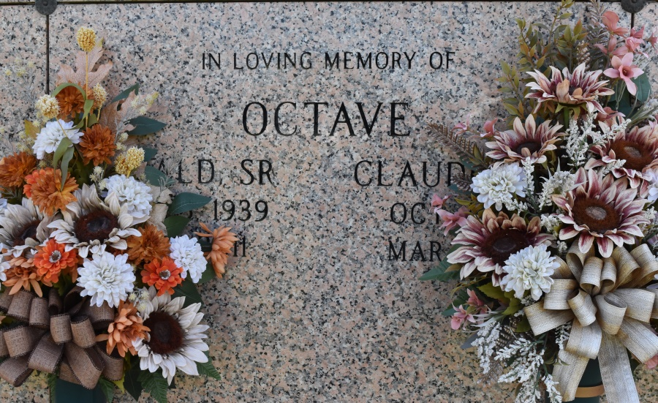

Ronald Vernon "Scrap" Octave, Sr. of Wallace, Louisiana passed away peacefully at his residence at the age of 72. He was the son of the late Frank and Beatrice Octave. Husband of Claudette Octave and father of Darwin (Charlene), Ronald, Jr., Shelley (Duane), Thaddeus (Marie), Seimon and Shane Octave, and Cornelius Roussell. Grandfather of Dandrea (Anthony) Carter, Shaea, Ron, Thaddeus, Dusharne, Tayja, Aspyn, Shiaa, and Rhyan. Two great grand daughters Daijah and Dallys Burham. Brother of Ella Mae Harrison, Idelma Roussell, and Sedious Octave and the late Stazzie Weber and Mildred Zeno. Brother- in-law of James and Lorraine Mitchell, Ernest and Dianne Cayette. Two devoted nephews, Kenneth Harrison and Raleigh Weber, Jr., a caretaker, Valecia B. Colton. He was also survived by a host of nieces, nephews, relatives, godchildren, and friends.

Relatives and Friends of the Family, Parishioners of St. Phillip Catholic Church, neighboring churches, Young Soldier Society, Pride of Brookstown Society, St. Joseph Hospice are invited to attend the funeral service at 11:00 a.m. at St. Phillip Catholic Church, Highway 18, Vacherie, Louisiana on Friday, December 23, 2011. Visitation begins at 8:30 a.m. until time of service. Father Christopher Decker officiating. Buriel St. Phillip Catholic Church Mausoleum. Funeral entrusted by The Baloney Funeral Home, LLC, 399 Earl Baloney Street, Garyville, Louisiana, 985-535-2540. Guests may express their condolences at [www.baloneyfuneralhome.com](http://www.baloneyfuneralhome.com/).

Published by The Times-Picayune, New Orleans, LA from Dec. 21 to Dec. 22, 2011.