Mary Cora (Weber) Oubre

December 4, 1909 - March 2, 1999

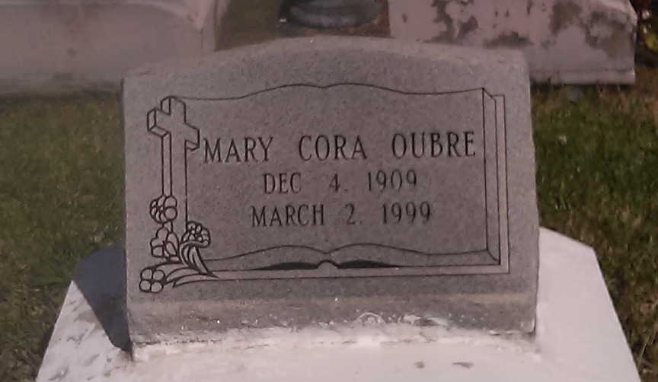

Photo by TMB

Mary Cora Weber Oubre, 89, a resident of Wallace, died March 2, 1999. She was the wife of the late John W. Oubre and mother of Mary Anne Julien, Carolyn Raphael, Carol Jean, John, Glenn, Jude and Rita Oubre.  
  
She was also the daughter of the late Paul and Josephine Ambrose Weber and sister of August Weber and Shirley Priestly, and was predeceased by two sisters and three brothers.  
  
She is also survived by 12 grandchildren and six great-grandchildren.

Unknown source

Contributed by TMB