Rose M. Oubre

April 1, 1937 – August 29, 2019

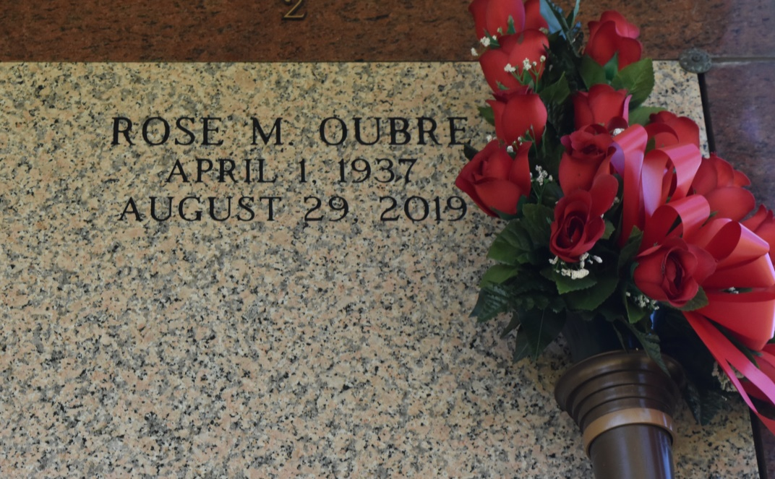

Rose Marie Oubre, a native of St. James Parish and a resident of Vacherie, La, passed away at the age of 82 on August 29, 2019. She is survived by her brother, Jerome Oubre, and two sister-in-laws, Jean Oubre and Carolyn Oubre. Rose is preceded in death by her parents, Joseph and Rozena Ambrose Oubre, brothers, Sidney, Charles, John, James, Vincent and Nathaniel Oubre, and sisters, Lois Walker and Geraldine O. Thomas.

A mass of Christian burial will be held at St. Philip Catholic Church, 1175 Highway 18, Vacherie, LA on Wednesday, September 11, 2019 at 11 a.m. Visitation will begin at 9 a.m. followed by the Rosary at 9:30 a.m. Entombment at St. Philip Catholic Church Cemetery. Final care has been entrusted to Treasures of Life Funeral Services, 315 E. Airline Hwy Gramercy, LA 70052.

Treasures of Life Funeral Services, Gramercy, Louisiana