Herman Patterson, Jr.

November 15, 1927 – September 22, 2005

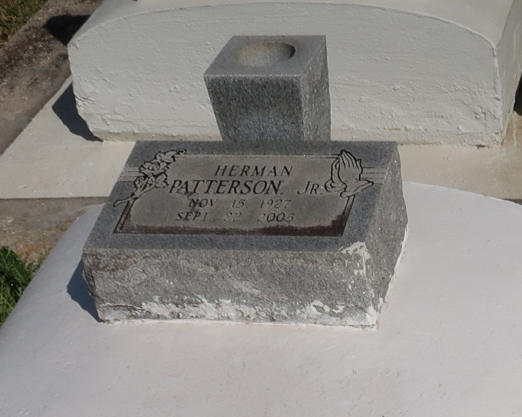

Herman Patterson, Jr. of New Orleans, LA passed away on September 22, 2005 at Northeast Baptist Hospital, San Antonio, TX. He graduated from Southern University School for the Deaf with a certificate in Shoe Repairs. Herman was a master shoe repairman for 40 years at Tip Top Shoe Repairs on S. Carrollton Ave. for the Sanopadre Family. Husband of Dolores Camp (1st marriage) and Vernice Patterson (2nd marriage). Stepfather of Vernon August and Ray Dantzler. Survived by 1 sister, Delores P. Smith; nephews, Kevin R. Smith (Barbara) and Kenneth Smith (Thea); great-nephews, Kevin Jr., Kenneth Jr., Antoine and Warren; great-nieces, Tamica and Ziekia; cousins and friends. Brother-in-law of the late Warren Smith. A funeral was held on Friday, September 30, 2005 from the St. Phillip Catholic Church, Vacherie, LA. Burial was in Church Cemetery. THE BALONEY FUNERAL HOME, L.L.C., Garyville, LA handled the arrangements.

Published by The Times-Picayune, New Orleans, LA on Oct. 16, 2005.