Curtis Poche, Jr.
Abt. 1956 – March 25, 2023

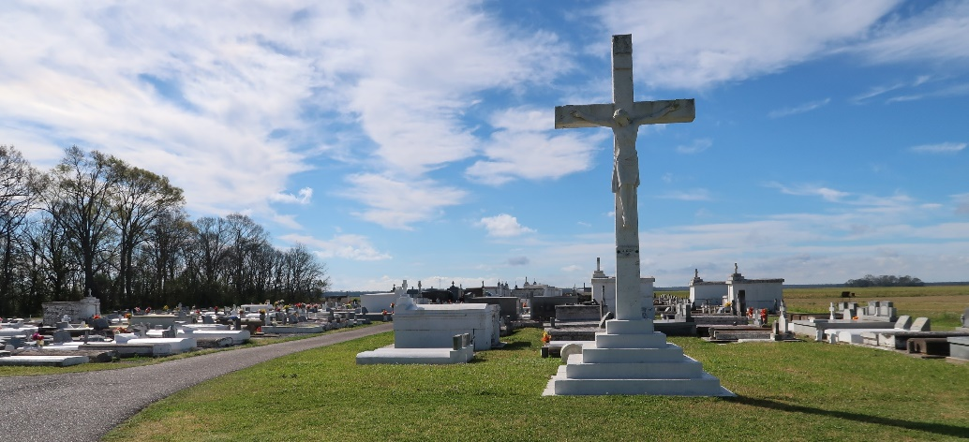

Curtis Poche Jr, "Zero" as he loved to be called was a Wallace, La resident, who entered into eternal rest on Saturday, March 25, 2023, at the age of 67. He was the husband of Mary "Theresa" Brown Poche. Loving and deeply devoted father to his 3 children: Brent Poche, Kenya Poche, and Triana Stewart (David); Grandfather "PaPa" to two grandsons: Javen "Tookie" Poche and Benz "B" Payne, one granddaughter: Tayden "LayLay" Poche. Also survived by his mother: Velma Poche; two brothers: Whitney and Shawn Poche; one sister: Patricia Bovie; his son-in-law: David Stewart, a host of nieces, other relatives, and close friends.

Preceded in death by his father Curtis Poche Sr.

A Mass of Christian burial honoring Curtis Poche Jr will be held on Wednesday, April 5, 2023, at St. Philip Catholic Church, 1157 LA 18, Vacherie, LA 70090. Visitation will begin at 9:00 am. Mass begins at 11:00 am. Interment will follow at St. Philip Catholic Church Cemetery, 1157 La 18, Vacherie, La 70090.

Treasures of Life Funeral Services, Gramercy, Louisiana
July 31, 2023

