Dorothy (Richardson) Pollard

August 6, 1934 – July 7, 2021

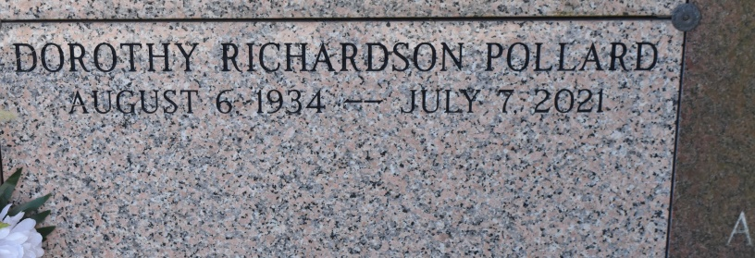

Dorothy Richardson Pollard departed this life on July 7, 2021, at the age of 86. She was born to Jeff Richardson and Clothile Taylor Richardson in Vacherie, Louisiana on August 6, 1934, and is the wife of the late John Thomas Pollard of Orange, Texas. Raised in Vacherie, she attended Southern University in Baton Rouge, earning a BS in Foods and Nutrition before completing a work-study internship at the Medical College of Virginia in 1955."Dot" (as her friends called her) soon moved to Texas and became the Registered Dietitian at Orange Memorial Hospital - the first Person of Color to hold the position in an era marked by the racial segregation of Jim Crow South. During this time, she was also the consulting dietitian of record at a local long-term care facility. In 1991, she combined her passion for nutrition and education, becoming the Food Services Director for West Orange Cove Consolidated Independent School district. There she ensured all children would eat a balanced diet from the "four basic food groups." Mrs. Pollard had deep roots in the Orange community. A devout Christian, she was an active member of Mount Olive Baptist church where she sang in the Senior Choir and was a key contributor to the annual Black History program. She was a proud Life Member of Delta Sigma Theta Sorority, Inc. - Orange Alumnae Chapter for over 60 years, a member of the Aggie Moms Booster Club, and could regularly be found supporting the West-Orange Stark Mustangs under the Friday night lights. In 2015, she returned to her hometown of Vacherie to live out her remaining years with family. She reunited with her home place of worship, First Baptist Church, and became a beloved member of the local community. Mrs. Pollard (Dot, Dottie, Auntie Dorothy, Mamma Pollard) will be remembered as a kind, affectionate, gentle, and giving spirit who was a selfless cheerleader for others. "A friend to all," she consistently offered uplifting words of encouragement, exuded a warm smile, or elicited a hearty laugh. Whenever she lent her guidance or advice, she left you with the same parting words of wisdom: "Keep God first." She is preceded in death by her parents Jeff and Clothile Taylor Richardson, husband John Thomas Pollard, sisters Louise Sheperd Luke, Josie Chaney, and Julia Celestine, nephews Wilfred Luke and Robert Sheperd, and niece Claudette Luke. She is survived by her son Jeffery Richard Pollard, sister Elizabeth Gant, and a host of nieces, nephews, other relatives, and friends. Funeral services will be held on Friday, July 16, 11 am at First Baptist Church, 1244 Magnolia Heights St., Vacherie, LA 70090. A memorial service will be held on Saturday, August 7, 2 pm at Price Mortuary, 1209 6th St., Orange, TX 77630.

Published by The Times-Picayune, New Orleans, LA from Jul. 13 to Jul. 16, 2021.