Geraldine (Ross) Rafiel-White

January 1, 1940 – April 17, 2021

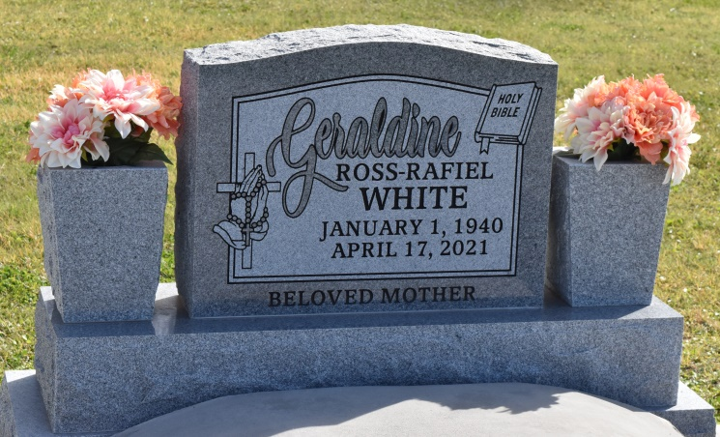

Geraldine Ross Rafiel-White was born on January 1, 1940 to Walter and Daisy Ross in New Orleans, LA. Geraldine gave her heart to Christ at an early age. She was baptized at Greater Woodville Baptist Church by her grandfather, pastor David Ross. Geraldine received her education through St. John the Baptist Parish school system. She was a 1959 graduate of 2nd Ward High School.

On May 28, 1960, Geraldine gave her hand in marriage to Joseph Rafiel at St. Phillip Catholic Church in Vacherie, Louisiana. From this union they were blessed with four children Susan, Joseph Jr., Daisy, and David. Throughout her life, she enjoyed traveling, shopping, playing bingo, and spending time with family. Geraldine had a passion for nurturing and caring for others. As a result, she worked as a devoted caregiver for many years. Later in life, Geraldine became a widow. She later remarried Fredrick White on January 6th, 1998. From this union, she gained three stepchildren- Victor, Sheila, and the late Cheryl.

On Saturday, April 17, 2021, Geraldine was surrounded by her family when God called her home. She is preceded in death by her parents, Walter Sr. and Daisy Armant Ross; grandparents, Rev. David and Natalie Ross; siblings, Mildred Hall, Marie Johnson, and Uriel Ross; brothers-in-law, John Gibson Sr., Andrew Raphael Sr., and Leroy Mitchell Sr.; sister-in-law, Irma Smith; and great-grandchildren, Alexis White, Rashad Rafiel and Khloe Jenkins.

Her love and memories will forever remain in the hearts of her children, Susan (Victor), Joseph Jr. (Crystal), Daisy (Micheal), and David (Colett); grandchildren, Renata, Jovan (Vincent), Cashmir (Lance), Natalie, Daniel, Victoria, Rickey, Joseph III, Hailey, and Spenser; great-grandchildren, Jade, Layla, Trace, Aiden, Lance Jr, Landon, Zoey, Liam, Jermi, Dante, Alana, and Harlem; siblings, Shirley Gibson, Janice Lumar (Wilfred), Earlene Stevens, Barbra Ann Jackson, Walter Ross Jr. (Lavina), Gerald Ross (Louise); sisters-in law, Olivia Ross and Brenda Mitchell; brothers-in-law, Warren Raphael and Edward Johnson; Godchildren, Marcelin Brisco, Eugene Adams, Catina Harry, and Keyambi Robinson; lifelong friend, Earlene Shexnayder; devoted neighbors Gloria and Lewis, and a host of nieces, nephews, cousins, and friends. Geraldine's presence will be missed by her family and friends, and her memory will be forever treasured.

A mass of Christian burial will be held on Saturday, April 24, 2021 at St. Anthony of Padua Church, 234 Angus Drive, Luling, LA 70070. Visitation will be held from 9am-11am. Service at 11am. Interment to follow at St. Philip Catholic Church Cemetery in Vacherie, LA. Final care entrusted to Treasures of Life Funeral Services, 315 E Airline Hwy., Gramercy, LA 70052. To share condolences and thoughts, and to sign guest book, please visit: [www.treasurefunerals.com.](http://www.treasurefunerals.com/) Due to CDC (Covid-19) guidelines and restrictions, masks and social distancing are required!!

Published by The Times-Picayune, New Orleans, LA from Apr. 21 to Apr. 24, 2021.