Archange “Dawn” Raphael

April 18, 1918 – November 25, 2006

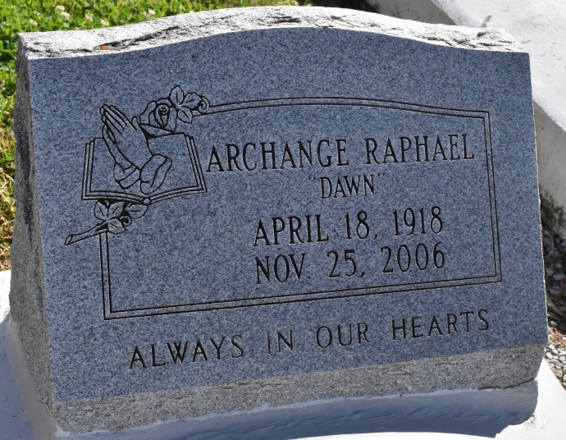

Archange ""Dawn'' Chopin Raphael of Vacherie, LA. at Thibodaux Regional Medical Center on Saturday, November 25, 2006. Beloved wife of the late Leonard Raphael, Sr. Daughter of the late Samuel and Felicia Chopin. Mother of Lynn, Herdle, Illoneis, Leroy, Leonard Jr., Patricia Landreaux, all of Vacherie, Ronald Raphael of Gramercy and Joyce Celestin of Spencerville, Maryland. Beloved sister of Leah Stewart. Sister-in-law of Claude Florent Jr. and Maude Chopin. Also survived by (9) grandchildren, (6) great grandchildren, (6) daughters-in-law, (2) sons-in-law, a host of nieces, nephews, other relatives and friends. A native and resident of Vacherie, LA.

Relatives and friends of the family, also priest and parishioners of St. Phillip and Our Lady of Peace Catholic Church. Employees of Northrop Gruman Shipyard, Silver Springs, Md. School System, St. James Lafourche Parish School System are invited to attend A Mass of Christian Burial on Saturday, December 2, 2006 a 11:00 a.m. from the St. Phillip Catholic Church, Hwy. 18, Vacherie, LA. Father Louis Oubre, celebrant. Visitation at the church after 9:00 a.m. Interment church cemetery. The Baloney Funeral Home, LLC. 399 Earl Baloney Dr., Garyville, LA 70051 985-535-2540 In charge of arrangements

Published by The Times-Picayune, New Orleans, LA on Dec. 1, 2006.