Illinois Raphael
November 25, 1944 – December 8, 2023

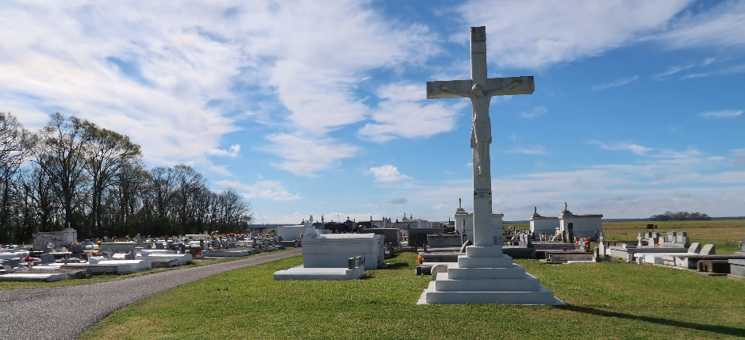

Illinois “Gummy” Raphael graced this world on November 25, 1944, born as the cherished third child to the late Archange “Dawn” Chopin and Leonard Raphael. Surrounded by the love of his family, he peacefully transitioned into eternal rest on December 8, 2023, at 11:02PM. His journey through life was one marked by dedication and love.
Illinois completed his education at Magnolia High, graduating with the esteemed class of 1962. Post-graduation, he embarked on a 42-year tenure at Avondale Shipyard, dedicating himself wholeheartedly to his work. On January 9, 1971, Illinois embarked on a lifelong partnership with Claudette Mary Steib, the love of his life. Their union was blessed in 1976 with the arrival of their beloved daughter, Raenell Angela. To Illinois, Raenell was a beacon of joy and admiration, his cherished “daddy’s girl.” In 2004, his world was further enriched with the arrival of his precious grandson, Payton Lee Haley, affectionately known as “P.” His grandson became his pride and the center of his joy.
Gummy’s passions were as vibrant as his spirit. A fervent sports enthusiast, he found solace on the baseball field, joyously playing with the Invaders and the Commodores during summer days. His loyalty extended to his favorite teams-the New York Yankees, New York Giants, and Notre Dame- where his unwavering support knew no bounds.
His heart was expansive, nurturing, and embracing. Illinois assumed roles of guidance and love as a father figure for Lavonzell Trench, Lacarmen Batiste, Edward Gaines, and Juan Nina. He shared boundless affection with Whitney, Michelle, and Michael Allen, Penny August, Sonya Gauthier Robertson, and Tiffany Adams-Roussell.
Illinois leaves behind a legacy woven with love and compassion. He is survived by his devoted wife of 52 years, Claudette; beloved daughter, Raenell; cherished grandson, Payton; and siblings, Herdle “Pop,” Leonard (Clarita), Ronald (Robin) Raphael, Patricia Landreaux, and Joyce Celestine. He will be dearly missed by sisters-in-law: Marvel Raphael, Dorothy Williams, Glenda (John) Greer, and Veronica Gordon; brothers-in-law: Daniel (Lorenza) Steib, Stephen (Mercede) Steib, and Claude (Doretha) Steib; aunt, Leah Stewart; six Godchildren: Monica Schexnayder, Lavonzell Trench, Angelica Mitchell, Michelle Steib, Keysa Honore, and Renette Lumar; a multitude of nieces, nephews, cherished relatives, and a vast circle of friends.
Illinois was preceded in death by his beloved parents, Leonard and Archange Raphael; brothers, Lynn and Leroy Raphael; brothers-in-law, Harvey Landreaux, Andrew Celestine, Wilbert Gordon, Jr., and Royal Williams; sisters-in-law, Carolyn and Dianne Raphael; and bonus brother, Lawrence Harrison.
In celebrating Illinois “Gummy” Raphael’s life, we honor his enduring legacy of love, kindness, and unwavering devotion to family and friends. His memory will live on in the hearts of all who were fortunate enough to have been touched by his warmth and generosity. May his soul find eternal peace in the embrace of fond memories and everlasting love.
A public visitation will be held on Friday, December 15, 2023, at Treasures of Life Funeral Services, 315 E. Airline Hwy., Gramercy, LA 70052 from 5PM-7PM. A Mass of Christian Burial will be held on Saturday, December 16, 2023, at St. Philip Catholic Church, 1175 LA-18, Vacherie, LA 70090. Visitation 9AM-10:45AM. Mass will begin at 11AM. Interment to follow at St. Philip Catholic Church Cemetery.

Treasure of Life Funeral Services, Gramercy, Louisiana
December 14, 2023

