Lydia Theresa Ricard
July 15, 1917 – December 21, 2012

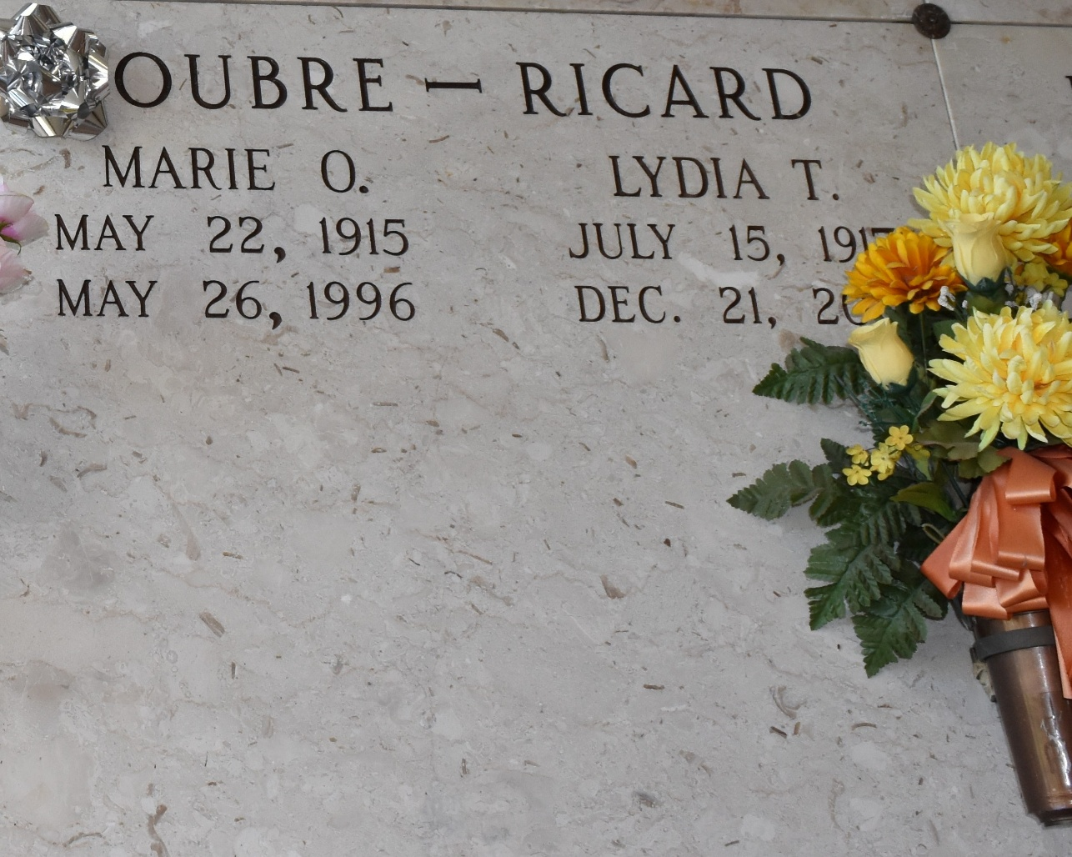

Lydia Theresa (Nanny Toon) Ricard, a retired principal, was welcomed into God's loving arms on Friday, December 21, 2012, at the age of 95. She was a native and resident of Vacherie, Louisiana.
She was preceded in death by her parents Stephanie Roussel Ricard and Emile Joseph Ricard Sr., brother Emile J. Ricard Jr. and sister Marie J. Oubre. Lydia is survived by her brother Eurick Ricard, sister-in-law Helen Rock Ricard, numerous nieces, nephews and cousins. She was a member of the Catholic Daughters of America and on the St. James Parish Library Board.
Relatives, friends, former students, members of the Catholic Daughters of America, Court of St. Phillip, and members of the St. James Parish Library Board are invited to attend a Mass of Christian Burial to celebrate Lydia's life, Friday, December 28, 2012 at 10;00 a.m. at St. Phillip Catholic Church, 1175 Hwy. 18, Vacherie, La. Father Louis Oubre officiating. Visitation will began at 8:00 a.m. and the rosary at 9:00 a.m. Interment in church mausoleum.
Arrangements by The Baloney Funeral Home LLC. 399 Earl Baloney Street, Garyville, La. 985-535-2540. Condolence may be offered at
www.baloneyfuneralhome.com. In lieu of flowers, please send donations to the Lupus Foundation at www.lupus.org.

The Times-Picayune, New Orleans, Louisiana
Dec. 26 to Dec. 28, 2012

