Margaret Joyce (Loup) Rodrigue

February 7, 1936 – April 12, 2007

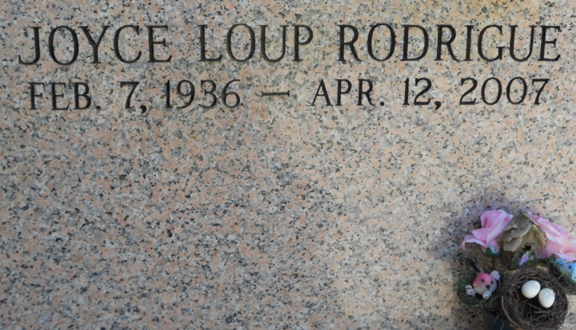

Photo by Team T Lo

Margaret Joyce Loup Rodrigue, a homemaker and a resident of Vacherie, died at 11 a.m. Thursday, April 12, 2007, at M.D. Anderson Cancer Center in Houston. She was 71 and a native of Wallace.  
 Visiting at St. Philip Catholic Church in Vacherie until Mass of Christian Burial, with the Rev. Louis Oubre, celebrant. Entombment in the church mausoleum. Arrangements by Ourso Funeral Home, Donaldsonville.  
 She is survived by a daughter, Debra Rodrigue, Houston; two sons and a daughter-in-law, David and Patti Rodrigue, Vacherie, and Kevin Rodrigue, Orlando, Fla.; two sisters, Myrna Steib, Luling, and Winona Matthews, St. Louis; two brothers, Clarence Loup, Vacherie, and Percy Loup, New Mexico; two grandchildren and a great-grandchild.  
 She was preceded in death by her parents, Nemour and Leonie Haydel Loup; and sister, Doris L. Giarrusso.  
 In lieu of flowers, memorial donations may be made to M.D. Anderson Cancer Center, Leukemia Research, P.O. Box 4486, Houston, TX 77210-4486, or www.mdanderson.org/gifts. For information on memorial funds please call (800) 525-5841 and include her name and for the memorial gift.  
 She was a member of St. Philip Church.  
  
The Advocate, Baton Rouge, Louisiana on April 15, 2007